CODEPHOENIX PRODUCTIVITY TOOLKIT
An Integrated Web Platform for Task Management, Habit Tracking, Focus Sessions and Real-Time Cowork Rooms
Capstone Project Report
Submitted by
Muhammad Mohid Alam (2023EBCS161)
Sharad Bhamidipati (2023EBCS373)
Anurag Suman (2023EBCS082)
Shayma Arif (2023EBCS506)
Group No. 129 (Code Phoenix)
Program: BSc Computer Science (Online Mode)
Institution: BITS Pilani, Work Integrated Learning Programmes
Academic Year: 2025-2026
Internal Supervisor: Raghu Babu

Declaration
We hereby declare that this capstone project titled “CodePhoenix Productivity Toolkit” is an original work carried out by us, and that it has not been submitted to any other university or institution for the award of any degree.
All sources of information, third-party libraries and hosted services used in the development of this project have been duly acknowledged in the References section of this report. The source code described here is available in full in the project’s public repository, and every quantitative claim made in Chapters 3 and 5 can be reproduced from that repository.

Muhammad Mohid Alam (2023EBCS161)
Sharad Bhamidipati (2023EBCS373)
Anurag Suman (2023EBCS082)
Shayma Arif (2023EBCS506)

Date: ____8/9/2026____

Abstract
Students and working professionals routinely struggle to hold three related activities together: finishing discrete tasks, sustaining recurring routines, and concentrating long enough to make progress on either. The established tools address these needs separately. Todoist and Google Tasks manage task lists, Habitica gamifies habits, and standalone timers handle focus. That leaves the user moving information between applications by hand and deciding priorities unaided, which is the very judgement that procrastination-prone users find hardest.
The CodePhoenix Productivity Toolkit is a full-stack web platform that unifies these functions in one authenticated workspace. It provides task management with subtasks, priorities, tags, natural-language entry and an Eisenhower-matrix view; recurring habit tracking at hourly, daily and weekly cadences with configurable active hours and weekdays, streaks and history analytics; Pomodoro-style focus sessions whose items are drawn directly from tasks and habits; a Today view that assembles the day as a timeline or an agenda from those same records; and Cowork Rooms, in which up to twelve authenticated users share live video and a synchronised list of what each is working on.
The system is a monorepo. The backend is FastAPI with SQLAlchemy 2, Alembic migrations, Pydantic validation and JWT authentication over PostgreSQL; the frontend is React 19 with TypeScript, Vite and Tailwind CSS. Cowork Rooms pair a WebSocket control plane for presence and task synchronisation with Cloudflare Realtime, whose Selective Forwarding Unit routes the media so that audio and video never traverse the application backend. That design replaced an earlier peer-to-peer mesh and more than doubled the supported room size.
Quality is enforced by an automated three-layer test pyramid of 480 tests: 180 backend pytest tests, 287 frontend Vitest and React Testing Library tests, and 13 Playwright end-to-end tests. GitHub Actions runs all of them on every push and pull request, with backend coverage gated at eighty-five per cent and currently measuring ninety-nine. The suite caught two release-blocking defects before release. The result is a working, tested and publicly deployed productivity platform that exceeds its original scope through the addition of real-time collaborative coworking.

Table of Contents
Declaration 2
Abstract 3
Table of Contents 4
List of Figures 7
List of Tables 9
List of Abbreviations 10
Chapter 1: Introduction 11
1.1 Overview of the Project 11
1.2 Problem Statement and Motivation 11
1.2.1 Review of Existing Systems 12
1.3 Objectives of the Capstone 13
1.4 Scope of Implementation 13
1.5 Organization of the Report 14
Chapter 2: Implementation Details 16
2.1 System Architecture and Design 16
2.1.1 Component Interaction 20
2.1.2 Data Flow 20
2.1.3 Data Model 21
2.2 Technology Stack 22
2.3 System Modules 23
2.3.1 Authentication Module 23
2.3.2 Task Module 23
2.3.3 Habit Module 24
2.3.4 Focus Session Module 24
2.3.5 Today and Schedule Module 24
2.3.6 Cowork Rooms Module (Beyond Original Scope) 25
2.3.7 Health and Cold-Start Handling 26
2.4 Key Algorithms and Logic 26
2.4.1 Habit Completion and Undo 26
2.4.2 Focus Session State Transitions 26
2.4.3 Habit Strength Scoring 27
2.4.4 Timeline Geometry for the Day View 27
2.4.5 Cowork Room Join and Media Negotiation 27
2.4.6 JWT Authentication Flow 28
2.5 Code Snippets 28
Chapter 3: Testing, Validation and Results 29
3.1 Test Plan 29
3.2 Test Cases 30
3.3 Results and Analysis 31
Chapter 4: Execution and Deployment Details 33
4.1 Execution Environment 33
4.2 Deployment Steps 33
4.3 Demo Screenshots 34
4.4 Demo Video 38
Chapter 5: Project Execution Evidence 39
5.1 Version Control Evidence 39
5.2 Weekly Progress Summary 41
5.3 Supervisor Interaction Summary 42
Chapter 6: Conclusion and Future Work 43
6.1 Summary of Implementation 43
6.2 Achievements 43
6.3 Limitations 44
6.4 Future Enhancements 44
References 46
Appendix A: User Manual 48
Tasks 48
Habits 48
Focus 48
Cowork 48
Appendix B: Installation Guide 49
Appendix C: Source Code 50
Appendix D: Demonstration Video 51

This table of contents is a live field. In Microsoft Word, select it and press F9 (or Ctrl+A then F9) to populate or refresh the page numbers.

List of Figures
Figure 1 High-level system architecture of the CodePhoenix Productivity Toolkit
Figure 2 Level-1 data flow diagram covering the REST plane, the WebSocket control plane and the media plane
Figure 3 Entity-relationship diagram of the persistent schema
Figure 4 Today view, timeline mode: the day laid out on a time grid, with scheduled habits, due tasks and at-a-glance counters
Figure 5 Today view, agenda mode: the same day as an ordered list grouped by part of day, with streaks and durations
Figure 6 Tasks page, list view: active and completed tasks with priority, quadrant label, due date and subtask progress
Figure 7 Task creation modal: priority, due date, time, duration and tag chips, with inline subtask entry
Figure 8 Tasks page, Eisenhower matrix view: tasks distributed across the four quadrants, with per-quadrant inline add and auto-categorisation
Figure 9 Habits page: the weekly grid, showing completed, missed and pending occurrences per habit alongside its cadence
Figure 10 Habit detail: habit-strength curve, long-run history, best streaks and day-of-week frequency
Figure 11 Focus session setup: duration, focus and break rhythm, derived plan preview, and item selection drawn from tasks and habits
Figure 12 Focus session running: current block, elapsed and remaining time, block and item progress, with attached items completable in place
Figure 13 Cowork room: participant tile, shareable room link, capacity indicator, media controls, and the shared “working on” list linked to the host’s live focus session
Figure 14 Commit history, 1 to 31 March 2026: First commit of the completed prototype in phase three along with phase 3 documentation.
Figure 15 Commit history, 1 to 30 April 2026: Building on top of the frontend prototype, first vercel deployment, started working on backend
Figure 16 Commit history, May 6 to July 6 April 2026: First work on tests, CI/CD setup, and refactoring work
Figure 17 Commit history, 6 to 9 July 2026: deployment hardening: Python version pinned for deploy, Supabase database configuration, and API loading states

Figure 18 Commit history, 22 to 24 July 2026: the day-planner service and route with their tests (both later withdrawn, see §6.3), a cowork peer-handshake fix, and Compose robustness
Figure 19 Commit history, 31 July 2026: the task feature layer: Eisenhower matrix, tags, command palette and its end-to-end coverage
Figure 20 Commit history, 3 August 2026: task editor, natural-language dates, habit creation editor, focus progress and the cowork room composer
Figure 21 Commit history, 4 to 5 August 2026: habit scheduling flexibility and the accompanying test updates
Figure 22 Commit history, 6 August 2026: final touches with bug fixes and UI/UX refinements.

List of Tables
Table 1 Comparison of existing productivity tools against the delivered system
Table 2 Technology stack of the delivered system
Table 3 REST and WebSocket surface exposed by the backend
Table 4 Composition of the automated test suite
Table 5 Representative test cases and results
Table 6 Weekly progress summary
Table 7 Supervisor interaction summary

List of Abbreviations
API Application Programming Interface
ASGI Asynchronous Server Gateway Interface
CI / CD Continuous Integration / Continuous Deployment
CORS Cross-Origin Resource Sharing
CRUD Create, Read, Update, Delete
DFD Data Flow Diagram
E2E End-to-End (testing)
ER Entity-Relationship
ICE Interactive Connectivity Establishment
JWT JSON Web Token
MSW Mock Service Worker
NAT Network Address Translation
ORM Object-Relational Mapper
P2P Peer-to-Peer
REST Representational State Transfer
RTL React Testing Library
SDP Session Description Protocol
SFU Selective Forwarding Unit
SPA Single-Page Application
STUN Session Traversal Utilities for NAT
TURN Traversal Using Relays around NAT
WS / WSS WebSocket / WebSocket Secure

Chapter 1: Introduction
Note: problem identification and the initial system design were completed as part of the preceding Study Project (Phases 1 to 3). This chapter summarises that groundwork and records what changed by the time the capstone was implemented.

1.1 Overview of the Project
The CodePhoenix Productivity Toolkit is a web-based productivity platform that brings task management, recurring habit tracking, focused work sessions and day planning into one authenticated workspace, instead of asking the user to operate several single-purpose tools side by side. Tasks carry deadlines, priorities, tags and nested subtasks, and can be viewed either as a filtered list or as an Eisenhower matrix. Habits recur hourly, daily or weekly, and can be restricted to particular hours of the day and particular weekdays so that a sleeping user is never marked as having missed anything. Focus sessions are Pomodoro-style timers whose attached items are drawn directly from the same tasks and habits, so completing work inside a session updates the rest of the workspace.
One module was added during the capstone phase that goes beyond the list agreed at design time: Cowork Rooms, in which up to twelve signed-in users share live video and a synchronised list of what each of them is currently working on. It is the concrete realisation of the “focus wars” idea that was recorded as an optional, nice-to-have item during planning. A second addition, an AI-assisted day planner, was built during the same phase and then withdrawn before submission; §6.3 explains why.
The system goes by two names, and both appear in this report. CodePhoenix is the team name (Group No. 129, “Code Phoenix”) and the name under which Study Project Phases 1 to 3 were submitted. FlowManager is the product name the application presents in its own interface: the sidebar, the sign-in screen and the room invitation copy all use it, which is why it appears in every screenshot here. Both names refer to the same system.

1.2 Problem Statement and Motivation
Many users find it difficult to manage daily tasks, recurring habits and focused work in a structured way. Distraction, weak planning, procrastination and inconsistency all reduce output, and the shift towards short-form content has measurably reduced the length of time people are willing to concentrate on a single item. The tools available to such a user are mostly specialised: they solve one part of the problem well and ignore the rest.
The result is fragmentation. A user’s deadlines live in one application, their routines in another and their timer in a third, and nothing joins them. Tools that do attempt to integrate these areas, such as OmniFocus, tend to carry a steep learning curve that defeats the users who most need help. Almost all of them still leave prioritisation and scheduling entirely to the user, which is exactly the judgement that procrastination-prone users struggle with.
The motivation for this project is both academic and personal. Academically, it applies system analysis, relational database design, full-stack web development, real-time communication and automated testing to a real problem, which maps closely onto the intended learning outcomes of the programme. Personally, every member of the team has lost time to poor planning and inconsistency, and wanted a single structured system rather than another single-purpose tracker.

1.2.1 Review of Existing Systems
Table 1 compares the tools that were examined during the Study Project against the capability set targeted by this capstone. The comparison is limited to the free tiers of each product, since that is the tier a student user would realistically adopt.
Tool | Tasks | Habits | Focus timer | Planning assistance | Shared / social focus
Todoist | Strong: projects, labels, natural-language entry | Only as repeating tasks; no streak model | None built in | Manual prioritisation | Shared projects, no live presence
Google Tasks | Basic lists and due dates | None | None | None | None
Habitica | Secondary to the game layer | Strong: streaks and rewards | None | None | Parties and quests, not live focus
OmniFocus | Very strong, steep learning curve | Via deferred repeats only | None | Review workflow, manual | None
Forest / standalone Pomodoro | None | None | Strong | None | Shared trees, no task context
CodePhoenix (this project) | Subtasks, priorities, tags, quick entry, Eisenhower matrix | Hourly / daily / weekly, active hours and days, streaks, history analytics | Configurable focus and break rhythm, items attached from tasks and habits | Today view: the day assembled from tasks, habits and focus sessions | Cowork Rooms: live video plus synchronised task lists for up to twelve users
Table 1: Comparison of existing productivity tools against the delivered system
The gap this project addresses is therefore not the absence of any one feature, but the absence of a single system in which task state, habit state and focus state inform one another, and in which planning assistance and shared accountability are available without leaving the workspace.

1.3 Objectives of the Capstone
Building on the primary and secondary objectives set out in the Study Project, the capstone phase set out to:
- Deliver a production-grade backend providing authentication, data persistence and business logic behind the previously frontend-only prototype.
- Implement full CRUD task management with subtasks, priorities, deadline handling, tags and an Eisenhower-matrix view.
- Implement a recurring habit engine supporting hourly, daily and weekly frequencies with configurable active hours, active weekdays, streaks and occurrence history.
- Implement Pomodoro-style focus sessions with a full pause, resume, complete and quit lifecycle, and with items linked to tasks and habits.
- Assemble the day automatically from existing task, habit and focus data, so that the user is not left to lay out their own schedule by hand.
- Design and ship Cowork Rooms (real-time presence, shared task lists and live video) as an extension beyond the original scope.
- Establish an automated test pyramid and a continuous-integration pipeline so that regressions are caught before merge rather than after deployment.
- Deploy the full stack to public infrastructure so that the system is usable outside the local development environment.
All eight objectives were met. Objective 6 was not part of the committed scope at design time and was delivered during the capstone phase. Objective 5 was met by the deterministic Today view described in §2.3.5, after an AI-backed planner was built, evaluated and then withdrawn for the reasons given in §6.3.

1.4 Scope of Implementation
The following are included in the delivered system:
- User registration, sign-in and JWT-based session management, with per-user data isolation enforced in the service layer.
- Task management with subtasks, priorities, due dates and times, tags, natural-language quick entry, and both list and Eisenhower-matrix views.
- Habit tracking with hourly, daily and weekly recurrence, active-hour and active-day windows, streaks, skip handling and a habit-strength history view.
- Focus sessions with a configurable focus-and-break rhythm, pause, resume, complete and quit, and items attached from tasks and habits.
- A Today view that lays the day out as a timeline or an agenda, assembled deterministically from tasks, habits and focus sessions.
- Cowork Rooms: shareable, capacity-limited rooms with live presence, synchronised task lists and SFU-routed video.
- A three-layer automated test suite and a GitHub Actions CI pipeline with branch protection on the main branch.
- A containerised local development stack and a deployed, publicly reachable production instance.
The following are excluded from the current scope:
- A native mobile application. The interface is responsive but is not packaged for app stores.
- AI-assisted day planning. A model-backed planner was built during the capstone phase and removed before submission; see §6.3.
- Guest (non-account) access to Cowork Rooms; a room invitation currently requires the recipient to sign in.
- Rooms larger than twelve participants, and recording or transcription of room media.
- Role-based access control, refresh tokens, email verification and password reset, which were assessed as out of scope for a single-user-per-account productivity tool at this stage.

1.5 Organization of the Report
Chapter 2 describes the implemented system: its architecture, the flow of data through it, the technology stack, each functional module, and the algorithms at the centre of the business logic. Chapter 3 sets out the test strategy, the composition of the automated suite, a representative sample of test cases and the results obtained. Chapter 4 covers the execution environment, the deployment pipeline and the running application, and includes annotated screenshots of every major screen. Chapter 5 presents project execution evidence: version-control history, milestone progress and supervisor interaction. Chapter 6 concludes with the achievements, the limitations that remain, and the work that would follow. References and appendices, including a user manual and an installation guide, complete the report.

Chapter 2: Implementation Details

2.1 System Architecture and Design
The delivered system is a three-tier web application with an additional real-time plane. Three diagrams describe it, and because all three are wide they are printed on landscape pages immediately following this section. Figure 1 is the as-built architecture across five functional groupings: the client layer, the API and application layer, the business-logic and service layer, the data layer, and the external services. Figure 2 is a level-1 data flow diagram. Figure 3 is the entity-relationship diagram of the persistent schema.
All three supersede the Study Project Phase 2 design, which showed the application layer as a Django REST API making a synchronous AI scheduling call. Neither of those holds now. The system was implemented on FastAPI, and the AI scheduling call was removed before submission for the reasons given in §6.3.
The sections that follow read against those figures: §2.1.1 walks the components, §2.1.2 traces the flow of data through them, and §2.1.3 explains the two schema decisions that are not self-evident from Figure 3.

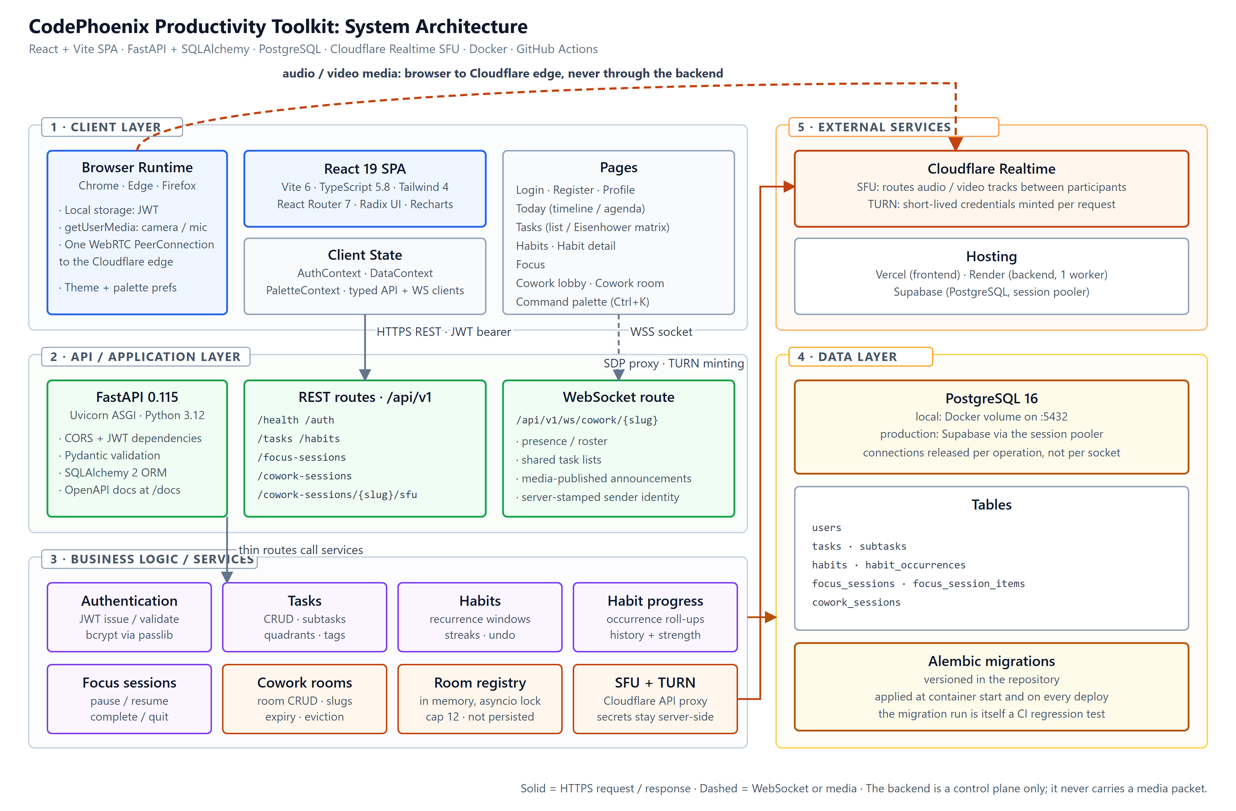
Figure 1: High-level system architecture of the CodePhoenix Productivity Toolkit
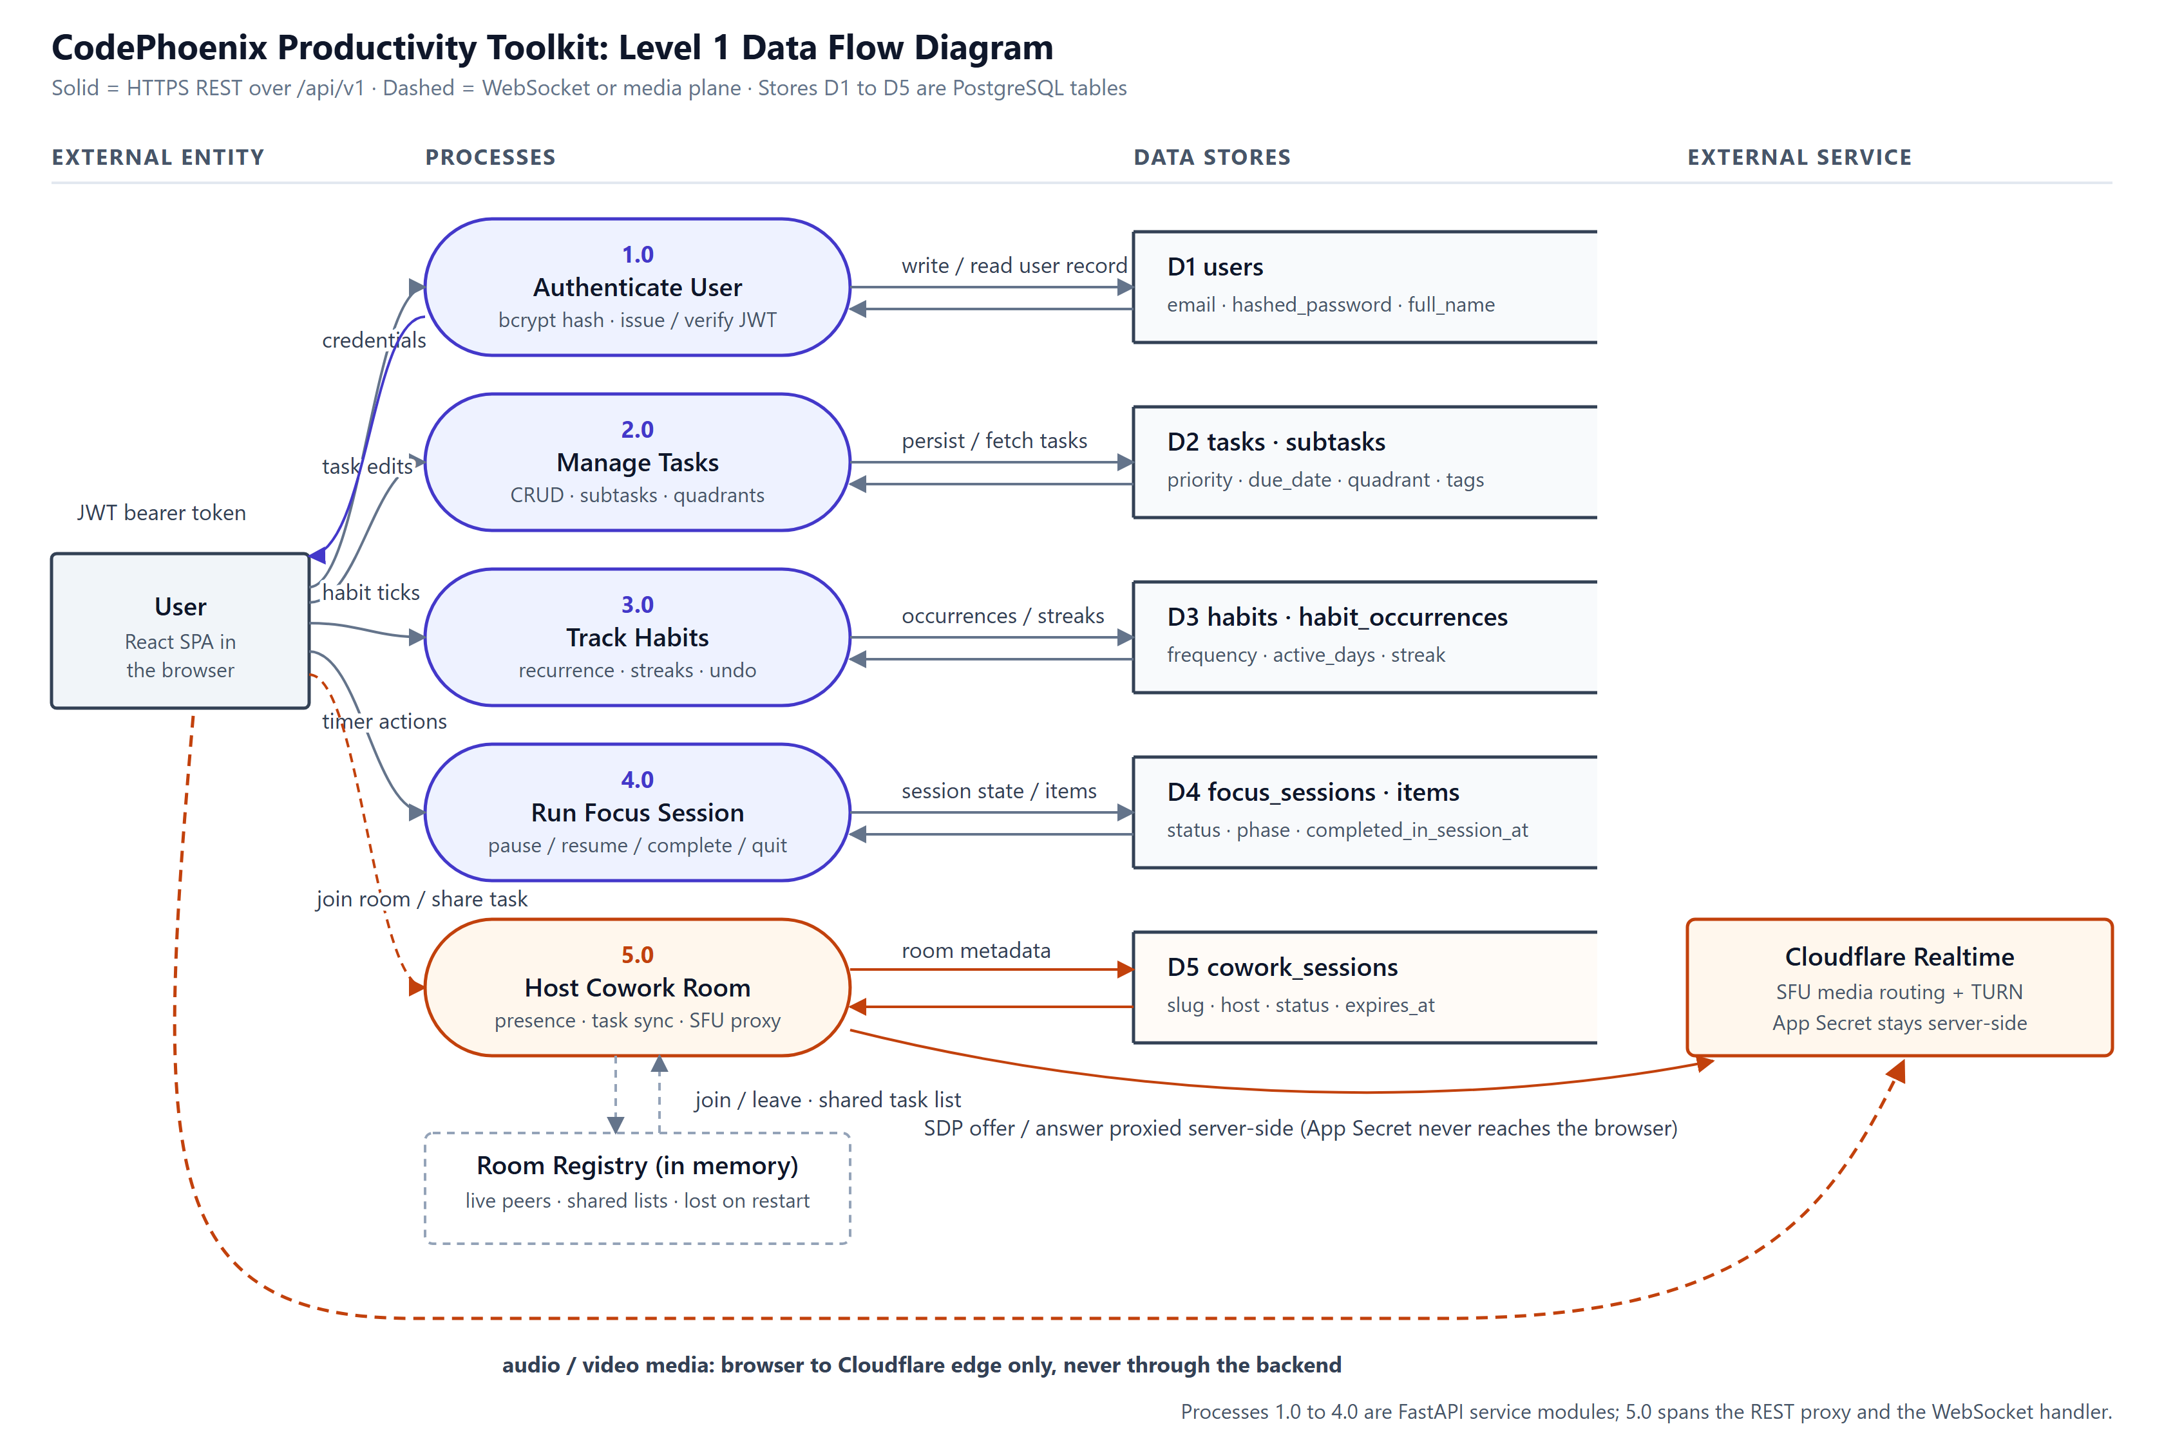
Figure 2: Level-1 data flow diagram covering the REST plane, the WebSocket control plane and the media plane
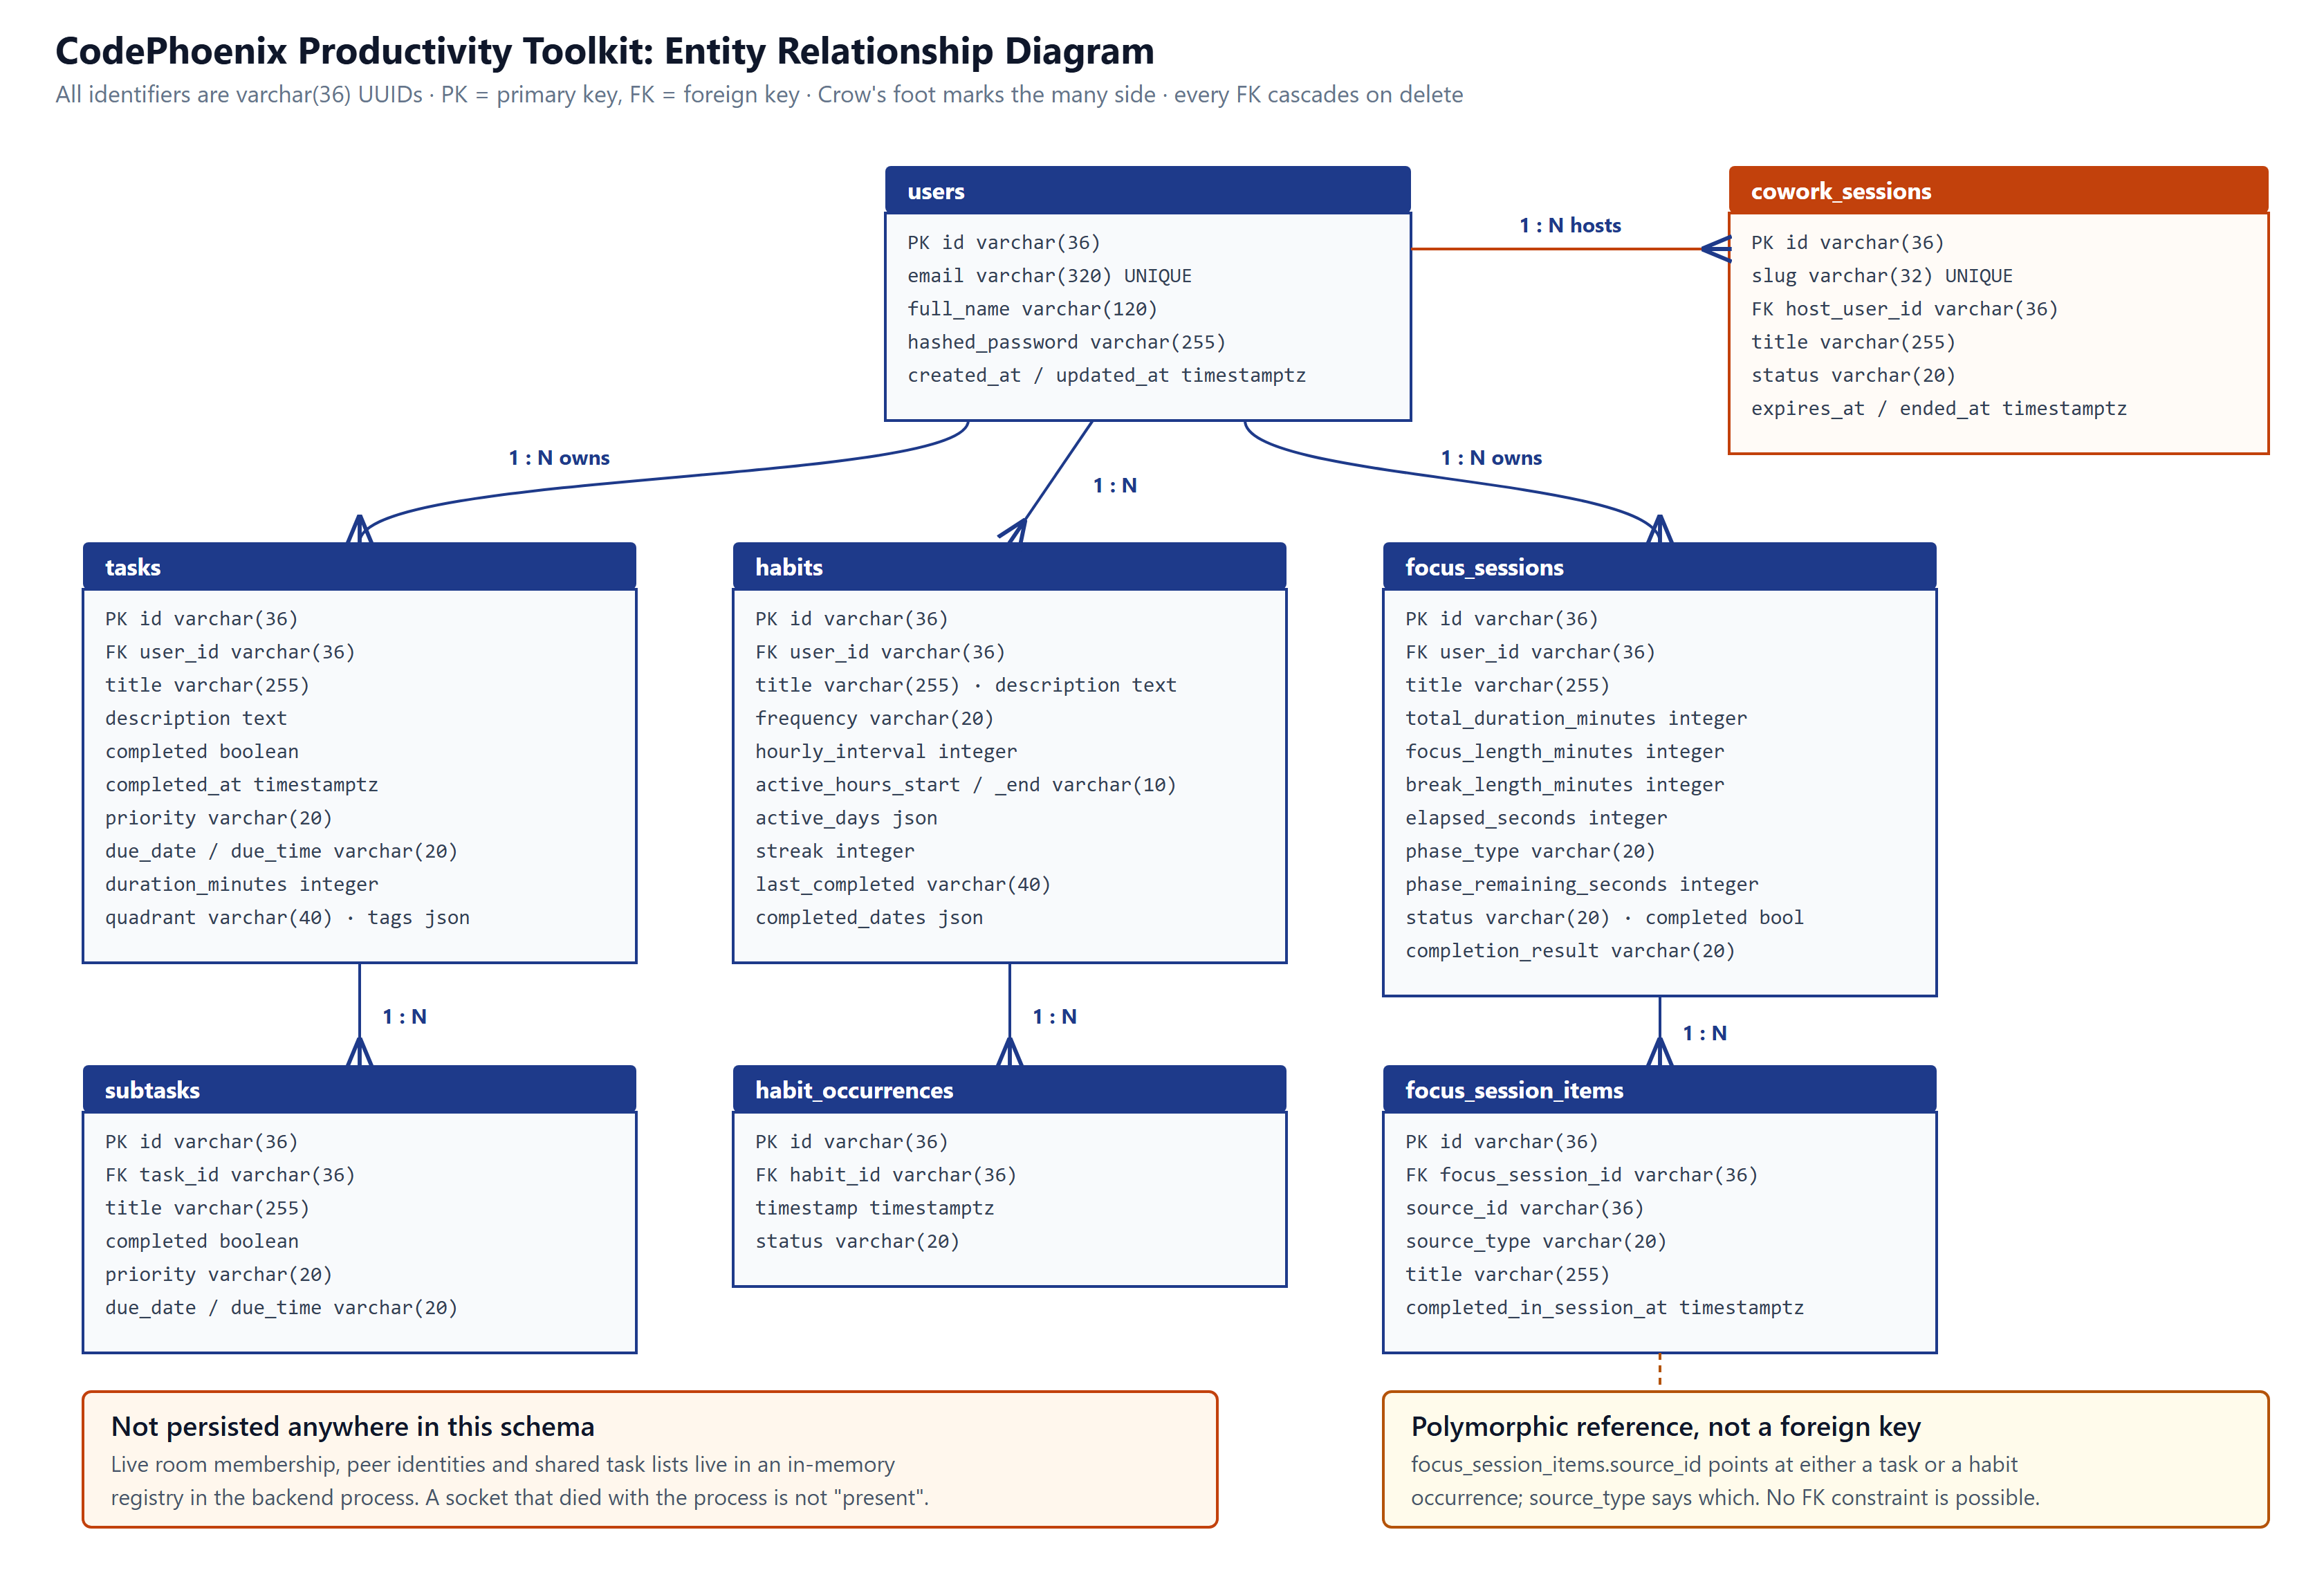
Figure 3: Entity-relationship diagram of the persistent schema

2.1.1 Component Interaction
The client layer runs entirely in the browser: a React 19 single-page application built with Vite and TypeScript, styled with Tailwind CSS, using React Router for navigation and React Context for shared state. A typed API client wraps all REST calls, and a separate WebSocket client manages the Cowork Rooms connection. The browser also owns two things the backend never sees, namely the JWT access token in local storage and the camera and microphone streams obtained through getUserMedia.
The application layer is FastAPI under a Uvicorn ASGI server, serving all REST traffic beneath /api/v1. CORS and JWT dependencies resolve the current user from a bearer token on every protected request, SQLAlchemy 2 provides the ORM, and Alembic manages schema migrations. Routes are grouped by domain, and one WebSocket route carries all Cowork Rooms traffic.
Beneath the routes, each domain has its own service module, which is what keeps the route handlers thin. There are service modules for authentication (JWT issue and validation, bcrypt hashing via passlib), tasks, habits, habit progress and streak roll-ups, focus sessions, cowork room persistence, the in-memory room registry, the Cloudflare SFU client and the TURN credential minter.
The data layer is PostgreSQL, which stores every persistent entity. Alembic migrations are versioned in the repository and run automatically at backend start-up, so the deployed schema stays in step with the deployed code on every release.
One external service is called at runtime. Cloudflare Realtime provides both the TURN relay and the Selective Forwarding Unit that routes room media, and the credentials for both stay server-side.
Around all of this sits the tooling. Docker Compose orchestrates the three services locally, and GitHub Actions runs the migration check, the backend test suite with a coverage gate, TypeScript type-checking, the frontend unit suite, a production build and the Playwright end-to-end suite on every push and pull request.

2.1.2 Data Flow
Figure 2 distinguishes the two planes that matter to this design: the request-response plane, on which every persistent change travels as a validated REST call, and the real-time plane, on which presence and task updates travel over a WebSocket while audio and video bypass the backend entirely.
A typical write follows one path. The user does something in the frontend, such as creating a task, completing a habit occurrence or pausing a focus session, and that action is sent as a validated REST request. FastAPI resolves the current user from the bearer token, applies the business rules in the relevant service module, and persists the result through SQLAlchemy. Reads follow the reverse path. Inside a Cowork Room a second path is active in parallel: changes to a participant’s shared task list are pushed over the open WebSocket so that every other participant sees them without polling.
The media plane is deliberately separate. Each participant holds one WebRTC peer connection to Cloudflare’s Realtime edge, and Cloudflare routes tracks between participants. The application backend never carries a media packet; it only proxies the session and track negotiation so that the Cloudflare application secret is never shipped to a browser. This is what makes the feature viable on free-tier hosting, which offers no UDP ingress at any plan level.

2.1.3 Data Model
Figure 3 shows the persistent schema: users; tasks and their subtasks, linked by task_id; habits and the individual habit_occurrences generated from them; focus sessions and their focus_session_items; and cowork sessions. Every foreign key cascades on delete, so removing a user removes everything they own. Two of these tables depart from the obvious design, for reasons that are easier to state here than to rediscover later.
The first is focus_session_items, which is not a conventional join table between two fixed entities. Each row carries a source_id together with a source_type discriminator, because an item attached to a session may be either a task or a habit occurrence. Storing the discriminator alongside the identifier avoids either a pair of nullable foreign keys or a separate table per source type. The cost is that the database cannot enforce the reference, so the service layer does.
The second is cowork_sessions, which stores only the durable facts about a room: its slug, host, title, status, creation time and expiry. It does not record who is currently inside. Live membership sits in an in-memory registry in the backend process and is lost if that process restarts, which is the correct behaviour rather than a shortcut. A socket that died with the process does not represent a participant who is still present, so persisting it would only create ghost entries that something else would then have to reap.

2.2 Technology Stack
Table 2 lists the technologies in the delivered system. Where a choice differs from the Phase 2 design, the difference is stated explicitly rather than quietly absorbed.
Layer | Technology | Notes
Frontend | React 19, TypeScript 5.8, Vite 6 | Component-based SPA, as originally planned
Styling and UI | Tailwind CSS 4, Radix UI, Recharts, lucide-react | Design system, accessible primitives and history charts
Backend framework | FastAPI 0.115 on Uvicorn (Python 3.12) | Deviation: Phase 2 planned Django. FastAPI was chosen for native async support, which the WebSocket layer depends on
ORM and migrations | SQLAlchemy 2.0, Alembic 1.15 | Schema versioned in the repository; the migration run is itself a CI regression test
Validation | Pydantic (pydantic-settings 2.8) | Request and response schemas; also drives the generated OpenAPI documentation
Database | PostgreSQL 16 (Supabase in production) | As planned in Phase 2
Authentication | python-jose (JWT), passlib with bcrypt 4.0.1 | Bearer-token sessions; bcrypt is pinned deliberately (see §3.3)
Real-time control plane | WebSockets (FastAPI native) | New: presence, shared task lists and track announcements
Real-time media plane | WebRTC via Cloudflare Realtime SFU | New: replaced an earlier peer-to-peer mesh (see §2.3.6)
TURN / STUN | Cloudflare Realtime TURN, public STUN | Short-lived credentials minted per request by the backend
Containerisation | Docker, Docker Compose | frontend, backend and db services for local development
CI/CD | GitHub Actions | backend, frontend and e2e jobs on every push and pull request
Hosting | Render (backend), Vercel (frontend), Supabase (PostgreSQL) | Free-tier deployment throughout
Testing | pytest, pytest-cov, httpx, Vitest, React Testing Library, MSW, Playwright | Three-layer automated test pyramid
Table 2: Technology stack of the delivered system
Table 3 lists the REST surface exposed by the backend. All routes are served beneath the /api/v1 prefix, and every route other than the health check and the two authentication entry points requires a valid bearer token.
Route group | Purpose
/health | Liveness probe, used by Render’s health check and by the frontend’s cold-start banner
/auth | Registration, sign-in and current-user resolution
/tasks | Task and subtask CRUD, including quadrant assignment
/habits | Habit CRUD, occurrence generation, completion and undo
/focus-sessions | Session lifecycle and session-item management
/cowork-sessions | Room creation, lookup by slug, ending a room, and the ICE configuration endpoint
/cowork-sessions/{slug}/sfu | Server-side proxy for Cloudflare session and track negotiation
WS /ws/cowork/{slug} | Presence, shared task lists and published-track announcements
Table 3: REST and WebSocket surface exposed by the backend

2.3 System Modules
Each functional area of the product maps to one service module on the backend and one page or page group on the frontend. The descriptions below follow that split, and refer back to Figures 1 and 3.

2.3.1 Authentication Module
This module handles registration, sign-in and current-user resolution. Passwords are hashed with bcrypt through passlib, and sessions are JWT bearer tokens decoded on each protected request through python-jose. Email addresses are stored lower-cased, so a user who registers as A@B.com can sign in as a@b.com. Duplicate-email registration is rejected, and every protected route is covered by a parametrised sweep in the test suite that asserts a 401 response when no token is supplied.

2.3.2 Task Module
The task module provides full CRUD for tasks and subtasks, covering nested creation, priority, due date and time, free-form tags and an Eisenhower-quadrant field. On top of that the frontend adds a natural-language quick-add parser: typing “pay rent tomorrow !high #home” creates a high-priority task due tomorrow, tagged “home”, with the recognised tokens stripped out of the title. An auto-categorisation helper assigns quadrants from the same data. It counts a task as urgent when it falls due within two days, and as important when its priority is high or medium.
Cross-user isolation is enforced in the service layer rather than at the route. A user who requests, updates or deletes another user’s task receives 404 rather than 403, so that the existence of an identifier belonging to another account is never disclosed.

2.3.3 Habit Module
A habit is modelled by a frequency of hourly, daily or weekly, an hourly interval, an active time-of-day window and a set of active weekdays, from which individual HabitOccurrence records are generated. Completing a habit increments its streak and appends to completed_dates; the operation is idempotent, so completing the same period twice does not increment the streak twice. Undoing a completion decrements the streak without allowing it to fall below zero and recomputes the last-completed marker from the remaining history. Hourly habits key their completion markers by full ISO timestamp; daily and weekly habits key by date.
The habit detail view derives a habit-strength score using an exponential decay with a thirteen-step half-life, so that thirteen consecutive completions from zero take the score to fifty per cent. History views compute their start date as the earliest of the habit’s creation date and its first recorded activity, which means that days before a habit existed are never rendered as missed.

2.3.4 Focus Session Module
Focus sessions are Pomodoro-style timers supporting pause, resume, complete and quit. Each action updates the session status and the matching timestamp, and an unrecognised action returns 400. A session is configured by total duration and by a focus-and-break rhythm, from which a pure planning function derives the sequence of focus and break segments shown in the setup preview and in the running session. Tasks and habit occurrences can be attached as session items and marked complete independently within the session through completed_in_session_at, which feeds the session history and the analytics groundwork already present in the schema.

2.3.5 Today and Schedule Module
The Today view is the application’s landing screen, and it is where task and habit data stop being two separate lists and become one day. It reads the user’s tasks, habit occurrences and focus sessions and lays them out in either of two modes. Timeline mode places each item on a time grid; agenda mode groups the same items by part of day. A week strip moves between days, and items can be dragged to a new time.
The layout arithmetic lives in pure functions rather than in the components, which is what makes it testable. The grid renders the hours from 06:00 to 23:00 at full scale and compresses the night hours so that anything scheduled overnight stays visible instead of falling off the top or bottom of the canvas. Habit occurrences are resolved against each habit’s cadence, active hours and active weekdays before they are placed, so a habit that is not due today never appears.
This module is deliberately deterministic. An earlier version called a hosted language model to order the day; that version was withdrawn before submission, and §6.3 records why. Everything the view shows is now derived from data the user has already entered.

2.3.6 Cowork Rooms Module (Beyond Original Scope)
A cowork session is a shareable room. A host creates one and receives an unguessable slug generated by secrets.token_urlsafe(8); participants join at /cowork/{slug} after authenticating, and the room expires twenty-four hours after creation. Presence and shared task lists are carried over a single WebSocket per room, backed by an in-memory registry guarded by an asyncio lock. Ending or expiring a room evicts everyone still inside it.
The module was first built on a peer-to-peer WebRTC full mesh, in which every participant held a connection to every other participant. That design did not survive contact with real networks. On restrictive Wi-Fi the failure mode was a black tile that never resolved, and the topology capped rooms at five people, because each client had to upload one stream for every other client in the room. The media plane was therefore migrated to Cloudflare Realtime’s Selective Forwarding Unit, so each participant now holds exactly one peer connection to Cloudflare’s anycast edge and Cloudflare routes the tracks onward.
The migration removed a whole class of failure, since clients connect to a well-known edge instead of to each other. It also decoupled upload cost from room size, which is what allowed the cap to rise from five participants to twelve. It deleted the most fragile code in the project as well: per-pair glare avoidance, ICE restarts and candidate buffering all went, rather than being carried forward and maintained. Nothing above the media plane changed. Rooms, slugs, the lobby, deep-link authentication, presence and task synchronisation all carried over untouched, which is exactly what the original split between control plane and media plane was meant to buy.
Two properties of the result matter for security and for correctness. All Cloudflare API calls are proxied by the backend and gated on live membership of the room in question, so the application secret stays server-side and an arbitrary authenticated user cannot push media through the project’s Cloudflare account. Separately, all negotiation for a given participant is serialised through a single queue in the client, because two concurrent renegotiations on one peer connection will corrupt its signaling state.
The SFU path was proven end to end against the live Cloudflare API. A synthetic publisher running inside the backend container published video through the proxy, and a receive-only browser subscribed to it and rendered the frames. Two-camera bidirectional video between real participants was then confirmed by manual testing on 30 July 2026.

2.3.7 Health and Cold-Start Handling
A dedicated health endpoint serves both Render’s health check and the frontend. Because the free hosting tier suspends an idle instance after roughly fifteen minutes, the room interface pings the health endpoint and displays a “warming up” state until the backend responds, before it attempts to open a socket. Reconnection with jittered backoff is treated as normal operation rather than as an error path, since every deployment and every wake-from-idle drops all open sockets at once.

2.4 Key Algorithms and Logic

2.4.1 Habit Completion and Undo
Idempotency is the property that matters here: a double-submitted completion must not inflate a streak, and an undo on a habit that was never completed must not drive the streak negative.
function completeHabit(habit, occurrence):
if occurrence.is_completed: return # idempotent, no double increment
occurrence.is_completed = true
occurrence.completed_at = now()
habit.streak += 1
key = iso_timestamp(now()) if habit.frequency == HOURLY else date(now())
habit.completed_dates.append(key)
habit.last_completed = now()

function undoHabit(habit, occurrence):
if not occurrence.is_completed: return # safe no-op
occurrence.is_completed = false
habit.streak = max(0, habit.streak - 1)
habit.completed_dates.remove(occurrence.key)
habit.last_completed = recompute_from(habit.completed_dates)

2.4.2 Focus Session State Transitions
on action in {pause, resume, complete, quit}:
if action not in allowed_actions: return 400
session.status = map(action) # e.g. pause -> PAUSED
session.<action>_at = now() # paused_at / ended_at, etc.
if action in {complete, quit}:
session.completion_result = action

on markItemComplete(session, item):
if item not in session.items: return 404
item.completed_in_session_at = now()

2.4.3 Habit Strength Scoring
The habit-strength curve shown on the habit detail page uses the smoothing constant popularised by the Loop Habit Tracker: a thirteen-step half-life applied per elapsed period.
SCORE_DECAY = 0.5 ** (1 / 13) # 13 consecutive completions from 0 -> 50%

score = 0
for period in periods_from(history_start, today):
score *= SCORE_DECAY
if completed(period):
score += (1 - SCORE_DECAY) * 100

# history_start = min(habit.created_at, first recorded completion or skip)
# so periods before the habit existed are never scored as misses

2.4.4 Timeline Geometry for the Day View
The day grid has to show a full twenty-four hours without wasting most of its height on the hours when nobody schedules anything, and without letting a 03:00 item disappear. It solves both by scaling the two ranges differently.
CORE_START = 06:00 · CORE_END = 23:00
HOUR_PX = 68 # working hours render at full scale
NIGHT_HOUR_PX = 10 # night hours stay visible but compressed

function minutesToY(m): # midnight-minutes -> pixel offset
m = clamp(m, 0, DAY_MINUTES)
if m <= CORE_START: y = m / 60 * NIGHT_HOUR_PX
elif m <= CORE_END: y = PRE_PX + (m - CORE_START) / 60 * HOUR_PX
else: y = PRE_PX + CORE_PX
+ (m - CORE_END) / 60 * NIGHT_HOUR_PX
return y + GRID_PAD

# yToMinutes is the exact inverse, so dragging a block to a pixel
# position and reading the time back is lossless.
# Habit occurrences are resolved against cadence, active hours and active
# weekdays before placement, so a habit not due today never appears.

2.4.5 Cowork Room Join and Media Negotiation
on join(slug, jwt):
room = getJoinableRoomOr404(slug) # open, not expired
async with registry.lock:
evictStalePeer(room, user) # one live socket per user
if len(room) >= MAX_ROOM_PARTICIPANTS: close(4403) # room full
peer = Peer(user, socket)
room[peer.peer_id] = peer
send(peer, welcome{ peers, max_participants, published_tracks })
broadcast(room, peer-joined{ peer.public_state() })

on media_published(peer, session_id, track_names):
peer.sfu_session_id = session_id # server-stamped, not client-trusted
peer.published_tracks = track_names
broadcast(room, media-published{ peer_id, session_id, track_names })

# every client operation is serialised through one queue, because two
# concurrent renegotiations on a single PeerConnection corrupt its state

2.4.6 JWT Authentication Flow
POST /auth/register -> hash(password) via bcrypt -> persist user
POST /auth/login -> verify(password, stored_hash) -> issue JWT(sub = user_id)

protected route -> decode_access_token(Authorization: Bearer <jwt>)
-> 401 if missing / expired / tampered
-> otherwise resolve current_user and continue

2.5 Code Snippets
Two short extracts illustrate conventions used throughout the codebase. The first is the backend test fixture that provides transaction-per-test isolation, described in §3.1. Each test runs inside a transaction that is rolled back afterwards, so tests neither leak state into one another nor need any cleanup code of their own.
@pytest.fixture()
def db():
connection = engine.connect()
transaction = connection.begin()
session = TestingSession(bind=connection)
app.dependency_overrides[get_db] = lambda: session
yield session
session.close()
transaction.rollback()
connection.close()
app.dependency_overrides.clear()
The second is the room capacity check, which is enforced on the server inside the registry lock rather than in the interface. The comment records why the cap has the value it does, so that a later reader does not have to rediscover the reasoning.
# With the SFU each participant uploads exactly one stream regardless of room
# size, so the cap is about download bandwidth and UI density, not upload.
MAX_ROOM_PARTICIPANTS = 12

async with self._lock:
room = self._rooms.setdefault(slug, {})
if len(room) >= MAX_ROOM_PARTICIPANTS:
raise RoomFullError

Chapter 3: Testing, Validation and Results

3.1 Test Plan
The testing strategy was written in response to two defects that had already reached the main branch and made the project unusable out of the box. Both would have been caught by even a minimal automated suite, and both now have dedicated regression tests. That history shaped the strategy: the goal is that the main branch always migrates, boots, registers a user and round-trips every feature, verified on every push and pull request.
Testing follows a three-layer pyramid. The reasoning is that the business logic is both where defects do the most damage and where they are cheapest to cover exhaustively, so most of the effort belongs there.
- Unit tests cover services, security helpers, mappers and pure frontend logic, run with pytest on the backend and Vitest on the frontend. This is the layer that holds the streak arithmetic, the focus-plan derivation, the natural-language date parser and the quick-add parser.
- API and integration tests cover every endpoint, exercised with pytest and httpx against a real PostgreSQL instance rather than SQLite, so that JSON column behaviour and migration behaviour match production.
- End-to-end tests are Playwright specs run against the full Docker Compose stack. This layer stays deliberately small, since the API layer already covers behaviour exhaustively and end-to-end tests are the slowest and most brittle to keep working.
Three decisions about the test infrastructure are less obvious than the layering. The backend test database is created strictly by alembic upgrade head and never by Base.metadata.create_all, which turns every test run into a migration regression test. That is a direct response to the defect that once stopped the backend container from starting at all. Each test then runs inside a database transaction that is rolled back afterwards, which keeps tests independent without any cleanup code. On the frontend, fake timers are used wherever the data provider is mounted, because it runs a one-second polling interval for active focus sessions that would otherwise make the tests non-deterministic.
Table 4 summarises the composition of the automated suite as measured in the repository at the time of writing.
Layer | Tooling | Scope | Tests
Backend unit | pytest | Security helpers, habit and focus services, SFU and TURN clients | 33
Backend API | pytest + httpx + PostgreSQL | Auth, tasks, habits, focus sessions, cowork rooms and socket, SFU proxy, cross-user isolation, health | 107
Frontend unit and component | Vitest, React Testing Library, MSW | API client, context mappers, guards, parsers, schedule and focus planning, habit statistics, pages and modals | 277
End-to-end | Playwright (Chromium) | Sign-up and sign-out, task lifecycle, habit lifecycle, focus lifecycle, session restore | 13 (5 specs)
Total |  |  | 413
Table 4: Composition of the automated test suite
All of it runs in GitHub Actions on every push and pull request, across three jobs. The backend job starts a PostgreSQL service container, applies migrations, then runs pytest under a coverage gate that fails the build below eighty-five per cent. The frontend job type-checks, runs the Vitest suite and produces a production build. The end-to-end job brings up the full Docker Compose stack, waits on the health endpoint and runs Playwright, uploading its report as an artefact when it fails. Branch protection on the main branch requires the backend and frontend checks to pass before a merge.

3.2 Test Cases
Table 5 lists a representative sample of the automated inventory across all three layers. The full suite is considerably larger, since parametrized CRUD, protected-route sweeps and cross-user isolation checks run across every resource type, so the table gives one case per behaviour class rather than an exhaustive listing.
ID | Description | Input | Expected output | Status
TC-01 | Password hash round-trip | get_password_hash("x" * 20), then verify | Verifiable hash; verify() returns true | Pass
TC-02 | JWT create and decode | create_access_token(sub), then decode | Decode returns the original subject | Pass
TC-03 | Expired or tampered token | Modified JWT sent to a protected route | 401 Unauthorized | Pass
TC-04 | User registration | POST /auth/register with a valid payload | 201 Created; response matches schema | Pass
TC-05 | Duplicate email registration | Register the same email twice | 400 Bad Request | Pass
TC-06 | Sign-in with wrong password | POST /auth/login with a bad password | 401 Unauthorized | Pass
TC-07 | Email case-insensitivity | Register A@B.com, sign in as a@b.com | Sign-in succeeds | Pass
TC-08 | Habit completion is idempotent | Complete the same occurrence twice in one period | Streak increments once, not twice | Pass
TC-09 | Habit undo floors at zero | Undo a habit that was never completed | No error; streak remains 0 | Pass
TC-10 | Habit history start date | Render history for a habit created mid-month | Days before creation are not marked missed | Pass
TC-11 | Focus session unknown action | PATCH a session with an invalid action string | 400 Bad Request | Pass
TC-12 | Focus session item completion | Mark an unknown item complete in a session | 404 Not Found | Pass
TC-13 | Focus plan derivation | 2 h total with a 50/10 focus-break rhythm | 2 focus blocks and 1 break, ending at the stated time | Pass
TC-14 | Cross-user task isolation | User B requests User A’s task by id | 404 Not Found; the id does not leak as 403 | Pass
TC-15 | Protected-route sweep | Call every protected route with no token | 401 Unauthorized on every route | Pass
TC-16 | Migration regression | alembic upgrade head against an empty database | Schema created without error | Pass
TC-17 | Cowork room lookup | GET a cowork session by the slug of an expired room | 404 Not Found | Pass
TC-18 | Cowork room capacity | A participant joins a room already at capacity | WebSocket closes with code 4403 (room full) | Pass
TC-19 | SFU proxy membership gate | Publish request from a user who is not in the room | Request rejected; Cloudflare is never called | Pass
TC-20 | API client base-URL join | getApiUrl() with and without leading and trailing slashes | Correctly joined URL; VITE_API_BASE_URL respected | Pass
TC-21 | Quick-add parsing | “pay rent tomorrow !high #home” | Title, due date, priority and tag parsed; tokens stripped | Pass
TC-22 | Auth context restore | Mount the app with a stored token | /auth/me is called and the session is restored | Pass
TC-23 | Auth context 401 handling | Stored token rejected by /auth/me | Token cleared and the user is returned to sign-in | Pass
TC-24 | Route guard | Unauthenticated user visits a protected route | Redirected to /login, preserving the return path | Pass
TC-25 (E2E) | Sign-up to dashboard to sign-out | Playwright: a fresh user completes sign-up | Dashboard loads; sign-out redirects guarded routes | Pass
TC-26 (E2E) | Task create, complete, reload | Playwright: create and complete a task, reload | Completion persists after reload | Pass
TC-27 (E2E) | Focus session lifecycle | Playwright: create, pause, resume, complete | Status transitions render correctly at each step | Pass
TC-28 (E2E) | Session restore | Playwright: sign in, then refresh the page | Session restored from the stored token | Pass
Table 5: Representative test cases and results

3.3 Results and Analysis
The test suite was built in four phases, all of which are complete. Phase 1 established the CI skeleton, the backend API tests and the migration step. Phase 2 added backend unit tests for the security helpers and the business services, gated at a minimum of eighty-five per cent coverage. Phase 3 added the frontend Vitest, React Testing Library and MSW suite. Phase 4 added the Playwright end-to-end smoke suite and its CI job. Backend coverage currently measures ninety-nine per cent of the service and route packages, against the eighty-five per cent gate.
At the time of writing the full frontend suite runs 277 tests across 29 files and passes in approximately eleven seconds, which is fast enough that developers run it before pushing rather than waiting for CI. The backend suite contributes a further 140 tests and the end-to-end suite 13, giving 413 automated tests in total.
Two release-blocking defects were found as a direct result of building this suite:
- A missing prepend_sys_path setting in alembic.ini caused alembic upgrade head to fail with a module-not-found error, which prevented the backend container from starting at all. The CI migration step is now a permanent regression test for it.
- An unpinned bcrypt dependency resolved to a version incompatible with the pinned passlib release, causing every registration request to return 500. The dependency is now pinned to 4.0.1 and a one-line password-hash round-trip test guards the behaviour.
The suite also caught regressions that never reached the main branch, of which two are representative. Hourly habit streaks were not being credited when a slot had only just opened, which the habit-statistics tests surfaced immediately. The second was a race in the cowork client that left peers stranded when the welcome roster arrived before the local camera stream resolved. The automated rig could not reproduce that one at all; it was found by the manual two-camera verification described in §2.3.6. The split is itself a useful finding. The automated suite is strong on logic and weak on real device and network behaviour, so that is where the manual checks were pointed.
No formal load testing was carried out, since the system is a single-user productivity tool on free-tier infrastructure rather than a multi-tenant service. Three operational measurements were taken instead, and all three affect how the deployed system feels to use. A cold request to the suspended free-tier backend completes in roughly forty seconds, which is why the interface shows an explicit warming-up state instead of appearing to hang. Once warm, health checks return in well under a second. Room media costs each participant one upload stream no matter how many people are in the room, because the SFU routes it rather than meshing it between peers, and that is what makes a twelve-participant room feasible on this infrastructure at all.

Chapter 4: Execution and Deployment Details

4.1 Execution Environment
Local development runs entirely under Docker Compose with three services. The frontend service runs the Vite dev server on port 5173, live-mounted for hot reload. The backend service runs FastAPI under Uvicorn on port 8000 and executes alembic upgrade head on container start. The db service runs postgres:16-alpine on port 5432, backed by a Docker volume so that data survives a restart of the stack.
The only prerequisite for a new developer is Docker itself; no local Python or Node installation is required to bring the stack up, although both are useful for running the test suites directly.

4.2 Deployment Steps
The production deployment is split across three free-tier providers, described declaratively in the repository so that it can be reproduced rather than reconstructed from memory.
- The backend runs on Render, deployed from a blueprint file as a single web service with exactly one Uvicorn worker. Its start command applies migrations before serving, so schema changes land automatically on every deployment. The secrets it needs (the database URL, the JWT signing key, the TURN key pair and the SFU application credentials) are marked as unsynchronised in the blueprint and set in the Render dashboard, so none of them enter the repository.
- The database is Supabase-hosted PostgreSQL, reached through its connection pooler. The WebSocket handler releases its database connection immediately after the join handshake instead of holding one for the lifetime of the socket, which would otherwise exhaust the pooler as rooms fill.
- The frontend is built on Vercel from the repository root, with an explicit rewrite so that client-side routes resolve to the SPA entry point. One environment variable is the only override point for the API origin, and the WebSocket URL is derived from it by scheme substitution instead of being configured separately, which removes a whole class of mismatch between the two.
- Allowed CORS origins are declared once in the deployment blueprint and reused for both HTTP CORS checks and WebSocket origin checks, so the two cannot drift apart.
- For real-time infrastructure, STUN is public, while TURN and the SFU are both Cloudflare Realtime applications with separate credentials. TURN credentials are short-lived, minted per request by the backend and served through a dedicated ICE-configuration endpoint, so long-lived secrets never ship inside the frontend bundle and the provider can be swapped without a frontend redeploy. If Cloudflare is unreachable, that endpoint degrades to STUN-only and reports the absence of TURN instead of failing the room.
The deployment was verified live while this report was being prepared: the frontend responds at its Vercel origin, and the backend health endpoint returns a successful response after the expected cold-start delay.

4.3 Demo Screenshots
The screenshots that follow were taken from the running application. They show the product under its in-application name, FlowManager, as explained in §1.1.
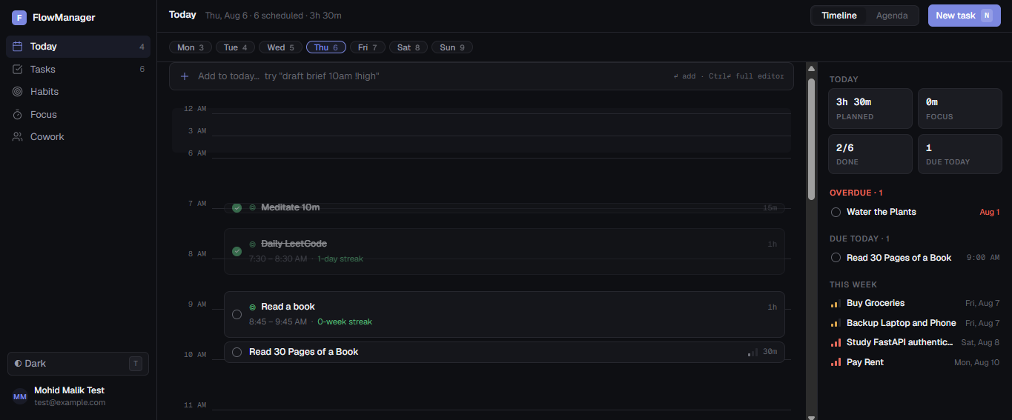
Figure 4: Today view, timeline mode: the day laid out on a time grid, with scheduled habits, due tasks and at-a-glance counters
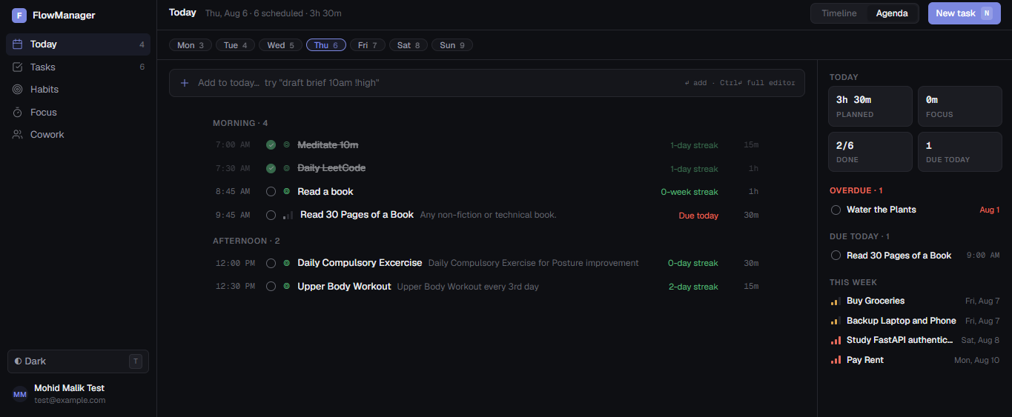
Figure 5: Today view, agenda mode: the same day as an ordered list grouped by part of day, with streaks and durations
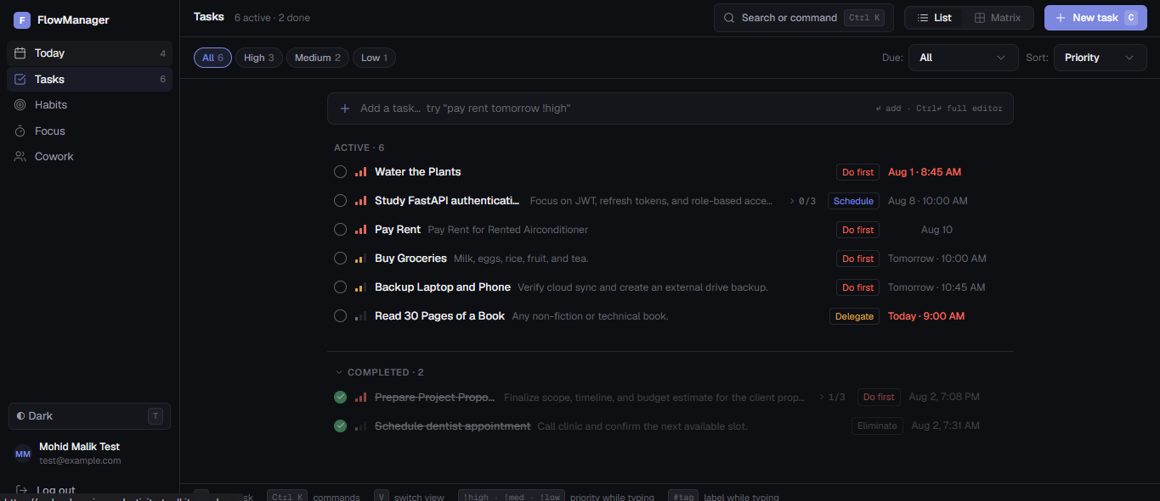
Figure 6: Tasks page, list view: active and completed tasks with priority, quadrant label, due date and subtask progress
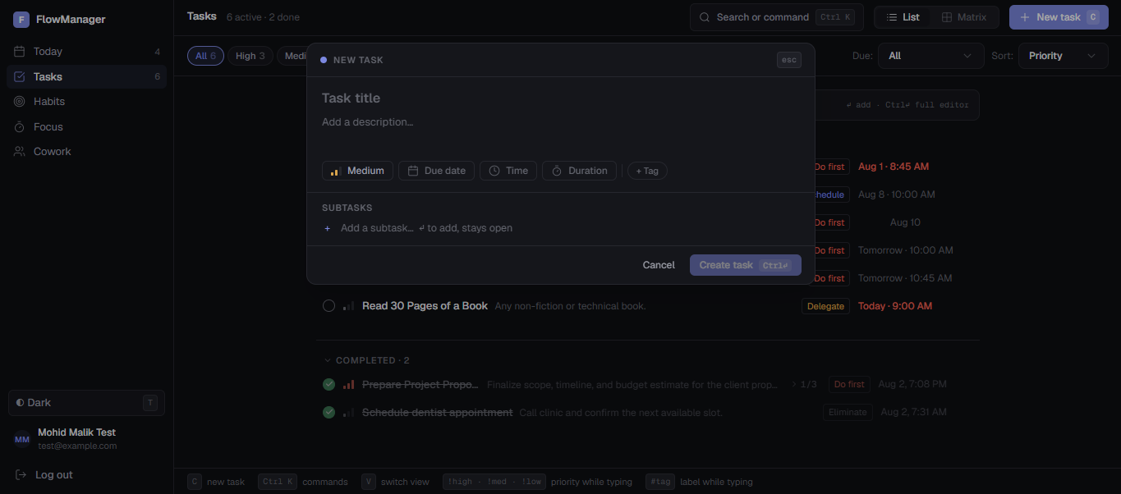
Figure 7: Task creation modal: priority, due date, time, duration and tag chips, with inline subtask entry
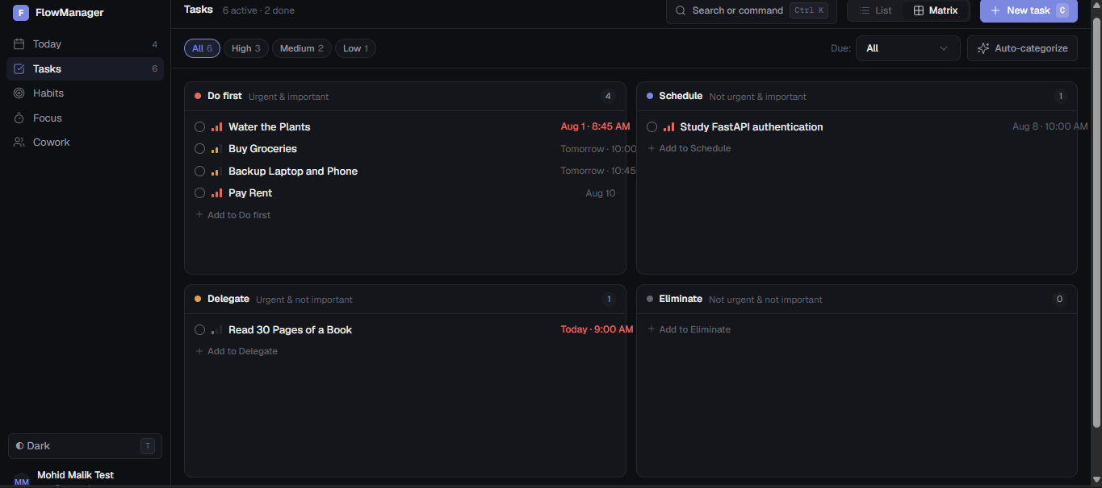
Figure 8: Tasks page, Eisenhower matrix view: tasks distributed across the four quadrants, with per-quadrant inline add and auto-categorisation
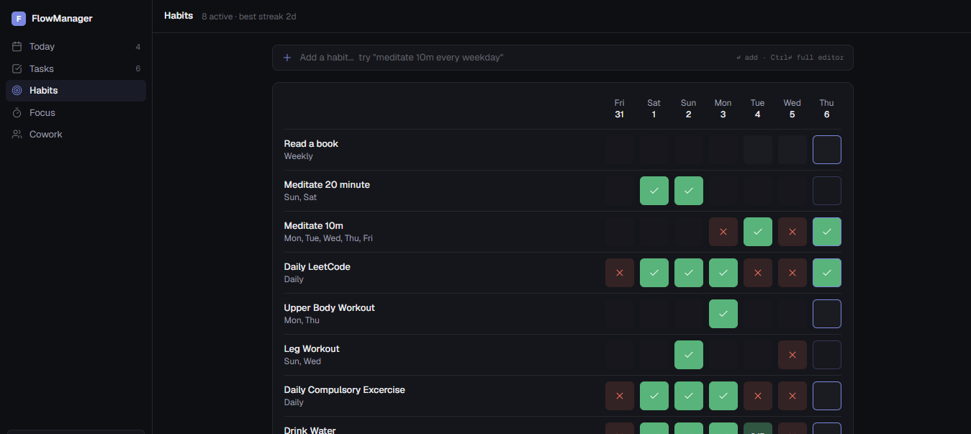
Figure 9: Habits page: the weekly grid, showing completed, missed and pending occurrences per habit alongside its cadence
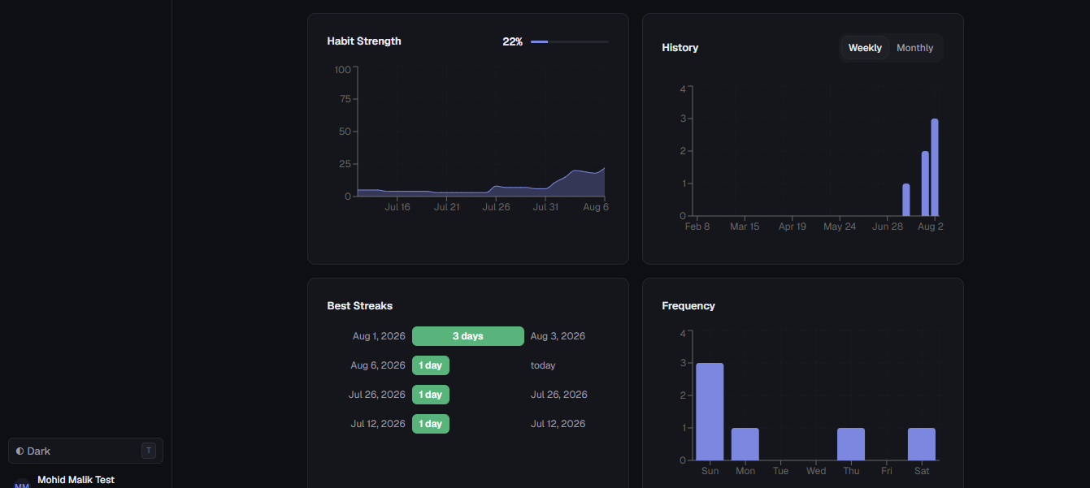
Figure 10: Habit detail: habit-strength curve, long-run history, best streaks and day-of-week frequency
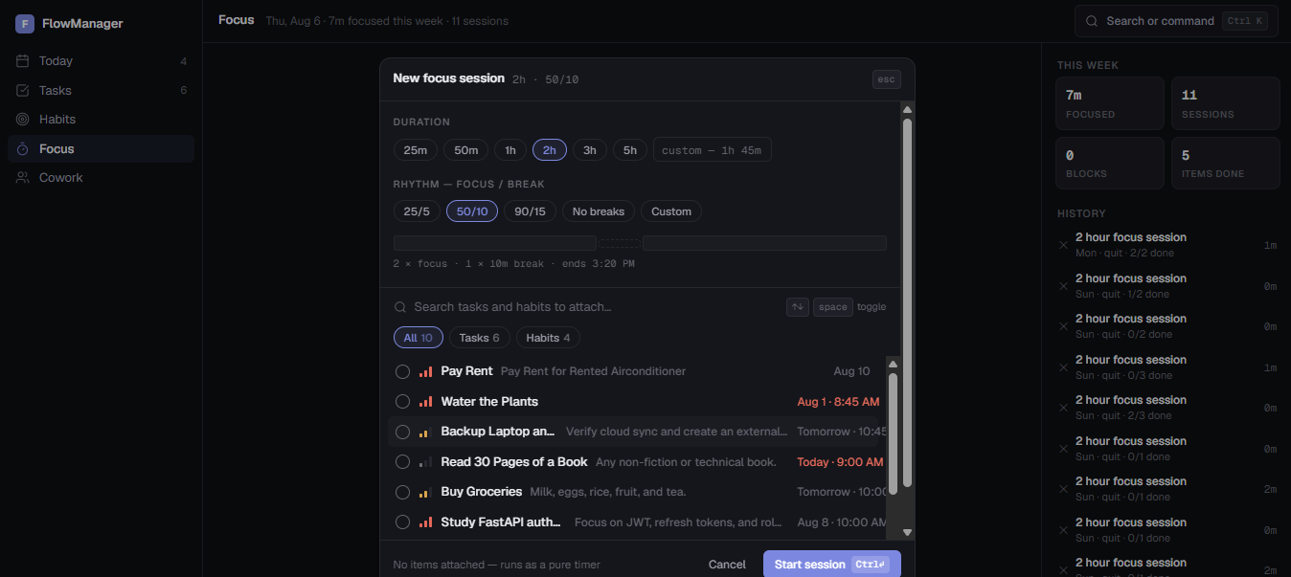
Figure 11: Focus session setup: duration, focus and break rhythm, derived plan preview, and item selection drawn from tasks and habits
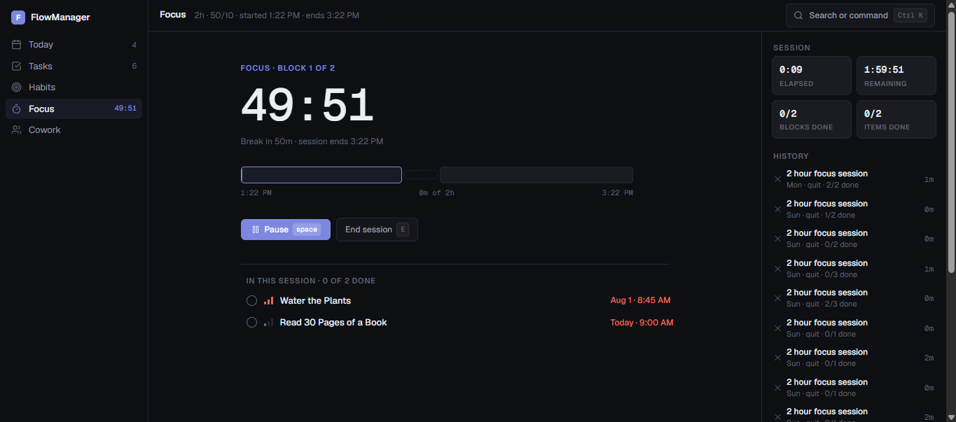
Figure 12: Focus session running: current block, elapsed and remaining time, block and item progress, with attached items completable in place
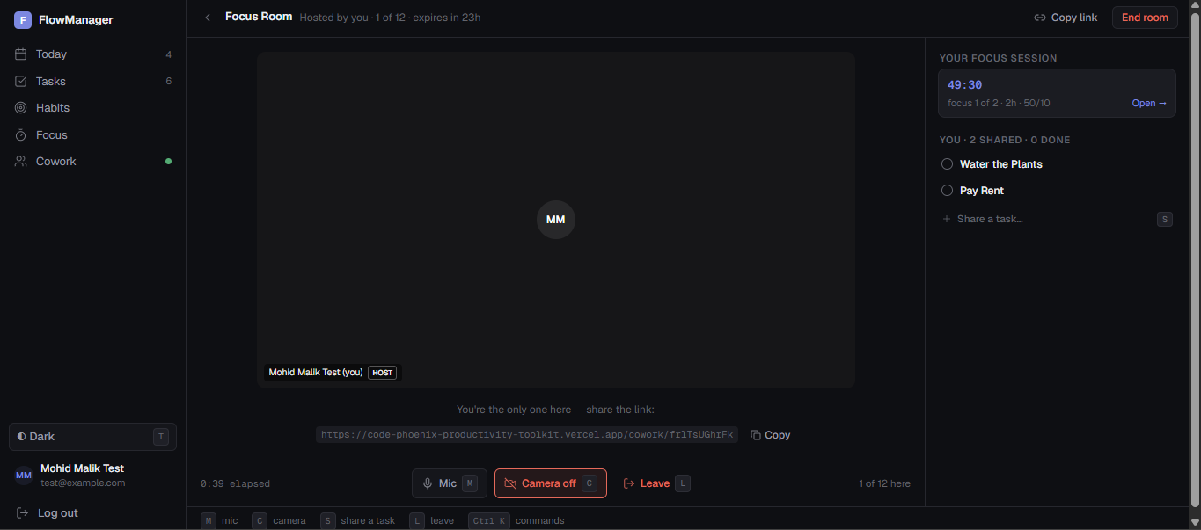
Figure 13: Cowork room: participant tile, shareable room link, capacity indicator, media controls, and the shared “working on” list linked to the host’s live focus session

4.4 Demo Video
Proof of concept (Study Project Phase 2): https://www.youtube.com/watch?v=en9wWjjlVaA
Frontend prototype walkthrough (Study Project Phase 3): https://youtu.be/pZxzrRLDrf0
Final capstone demonstration video: https://www.youtube.com/watch?v=TZcZFXkjK5s

Chapter 5: Project Execution Evidence

5.1 Version Control Evidence
The project is developed in a single public Git repository: https://github.com/Alamicrodev/CodePhoenix-ProductivityToolkit
The repository holds 100 commits from four contributors, spanning 3 March 2026 to 3 August 2026. Work is merged through pull requests with CI status checks attached, which is visible in the history below as the pass and fail markers beside individual commits. Commit messages follow a conventional prefix scheme (feat, fix, test, docs, refactor, chore), which makes the history readable as a record of what was built when and is the basis of the milestone summary in §5.2.

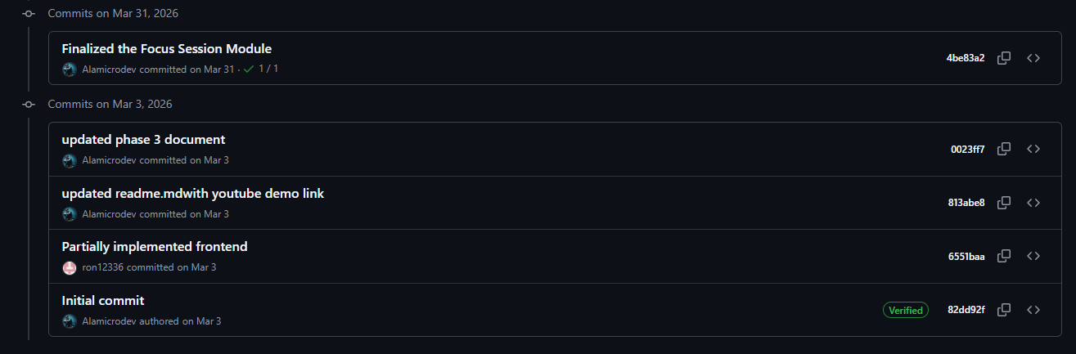
Figure 14: Commit history, 1 to 31 March 2026: First commit of the completed prototype in phase three along with phase 3 documentation.

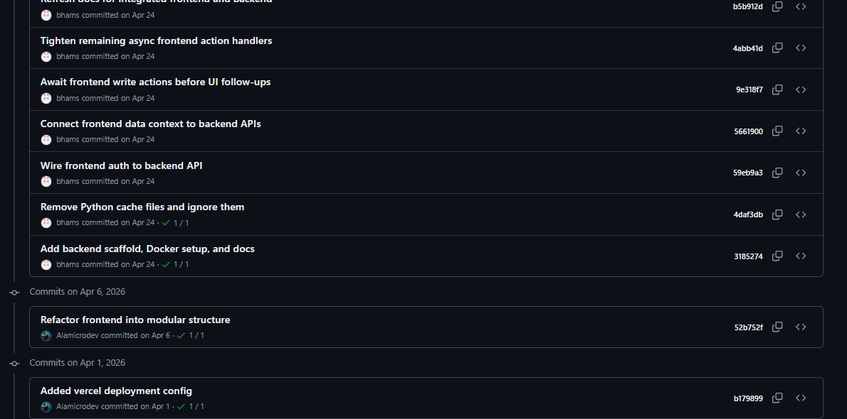
Figure 15: Commit history, 1 to 30 April 2026: Building on top of the frontend prototype, first vercel deployment, started working on backend

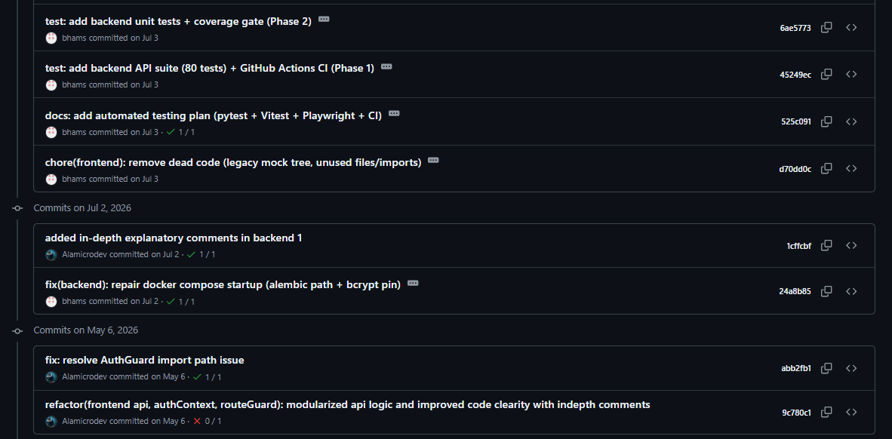
Figure 16: Commit history, May 6 to July 6 2026: First work on tests, CI/CD setup, and refactoring work

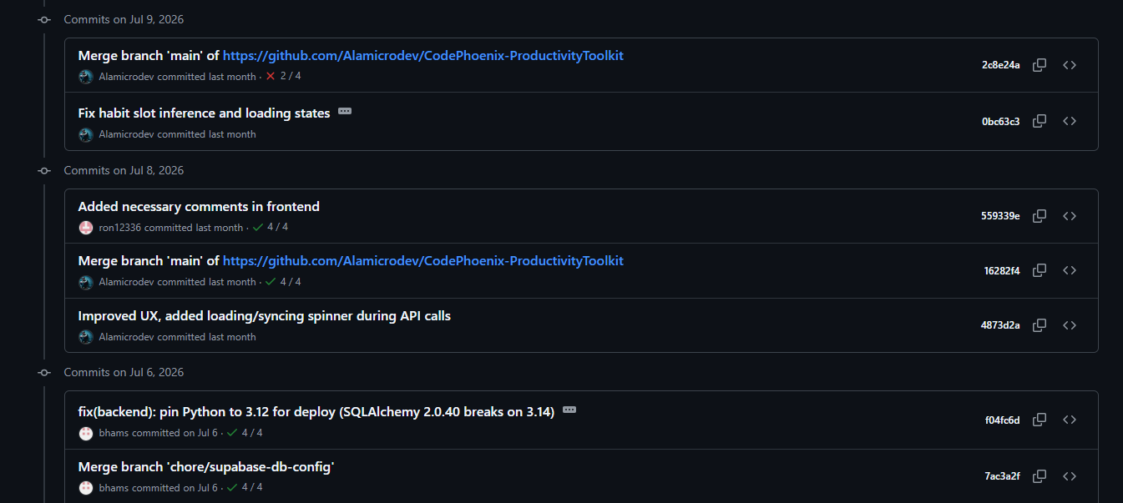

Figure 17: Commit history, 6 to 9 July 2026: deployment hardening: Python version pinned for deploy, Supabase database configuration, and API loading states

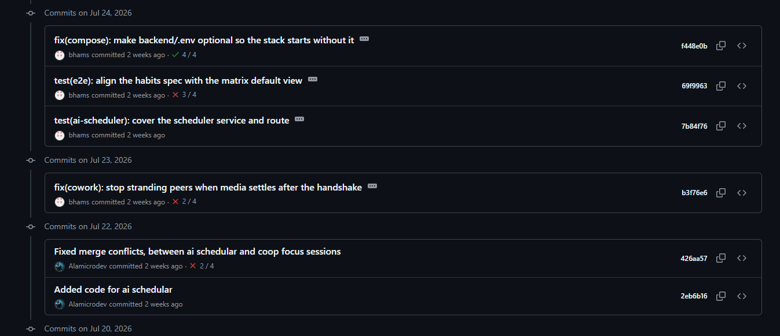
Figure 18: Commit history, 22 to 24 July 2026: the day-planner service and route with their tests (both later withdrawn, see §6.3), a cowork peer-handshake fix, and Compose robustness
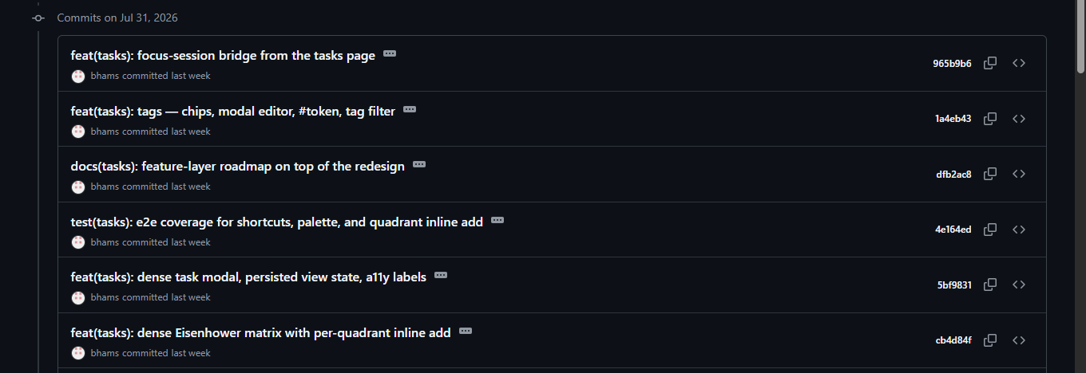
Figure 19: Commit history, 31 July 2026: the task feature layer: Eisenhower matrix, tags, command palette and its end-to-end coverage
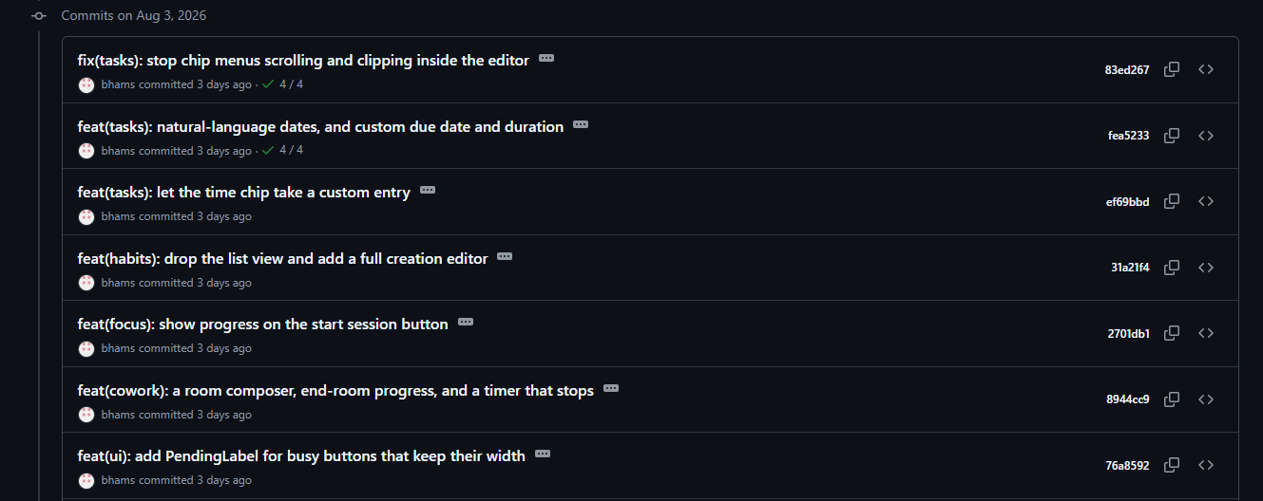
Figure 20: Commit history, 3 August 2026: task editor, natural-language dates, habit creation editor, focus progress and the cowork room composer

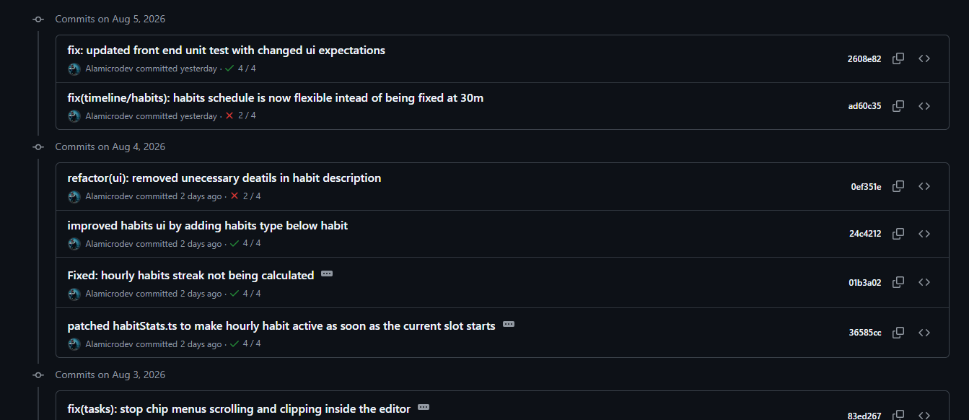
Figure 21: Commit history, 4 to 5 August 2026: habit scheduling flexibility and the accompanying test updates

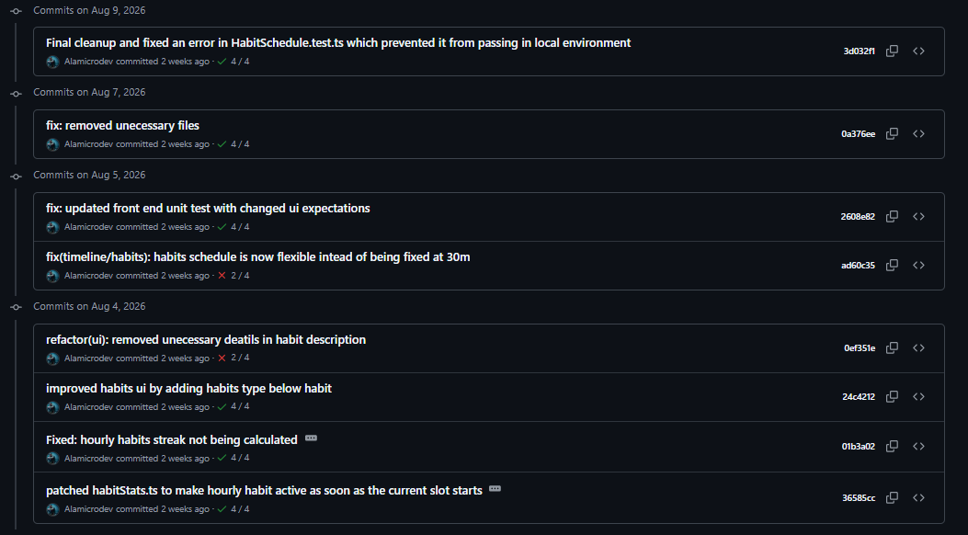
Figure 22: Commit history, 9 August 2026: final touches with bug fixes and UI/UX refinements.

5.2 Weekly Progress Summary
Table 6 summarises progress at milestone level. The task and completion columns are derived from the repository history and the Study Project submissions; the supervisor remarks column is to be completed by the team from their own meeting records before submission.
Week | Task planned | Task completed | Supervisor remark
1-3 | Problem identification and planning | Problem Identification and Planning Report submitted (Study Project Phase 1) | (Planning) Problem well scoped and the plan is realistic. Phase 1 report is clear and complete & approved to move into design.
4-6 | Architecture, database schema and technology-stack justification | System architecture, ER diagram and stack justification completed (Phase 2) | (architecture): Sound architecture and ER schema, technology-stack choices are well justified. Good foundation for buildout.
7-9 | Prototype, partial implementation and risk analysis | Frontend prototype on local storage completed; Phase 3 report submitted | (prototype): Working prototype demonstrates feasibility, and the risk analysis is thoughtful. Advised to prioritise moving off local storage to a real backend.
10-13 | Finalize Focus Session Module in Front-end which is severely buggy and limited in the prototype. | Focus Session Module finalized and working in the Front-end. | Satisfactory progress. Focus Session Module successfully finalized and functioning as expected in the front-end. Advised to polish design and move off the local storage to a real backend.
14-18 | Backend build-out: models, authentication, services | FastAPI backend implemented: auth, tasks, habits and focus sessions, with Alembic migrations | (backend): Strong progress , auth, tasks, habits and focus sessions all implemented, with proper Alembic migrations. Core services are in good shape.
19-22 | Refactor code, add necessary comments and improve overall code quality | Added necessary comments, made code modular and more readable. | Satisfactory progress. Code refactoring is completed with improved modularity and readability. Suggested adding automated tests.
22-25 | Automated testing and continuous integration | Basic work on automated testing started but no major goal completed, as team got busy in exam days. | Limited progress. Strongly advised to get back on track to add automated testing and public deployment.
25-30 | Automated testing and continuous integration | pytest, Vitest and Playwright suites with the GitHub Actions pipeline and branch protection in place | (testing/CI): Comprehensive coverage across unit, component and end-to-end layers. CI pipeline and branch protection show good engineering discipline. Suggested to improve UI/UX design.
31-32 | Deployment and day planning, Work on AI scheduler | Deployed to Render, Vercel and Supabase; a model-backed AI day planner was built, evaluated and later withdrawn due to lack of Api credits | (deployment): Successful deployment across all three services. Sensible, mature decision to withdraw the AI day planner after evaluation rather than ship an unreliable feature. Suggested to improve UI/UX, and work on more features.
32-34 | Cowork Rooms (new scope) | Rooms, presence and task synchronisation delivered; media plane migrated from P2P mesh to the Cloudflare SFU and verified with two live cameras, major UI change with scheduling view replacing the dashboard | (Cowork Rooms): Ambitious new scope delivered well. The migration to the Cloudflare SFU was the right call for scalability, and good to see it verified with live cameras.
34-35 | UI/UX and front-design improvement. Major overhaul of the feature layer and hardening. | Task editor, Eisenhower matrix, tags, natural-language dates, habit creation editor and focus progress delivered | (features): Rich, well-rounded feature set,the product now feels complete and polished.Good attention to usability.
36-38 | Documentation and final review | Capstone documentation compiled and verified against the repository | (documentation): Thorough documentation, closely aligned with the repository. Project completed to a high standard.
Table 6: Weekly progress summary

5.3 Supervisor Interaction Summary
Table 7 records the major review points across the Study Project and capstone phases.
Review | Date | Material presented | Key feedback received
1 | 02/02/2026 | Problem Identification and Planning Report (Study Project Phase 1) | Problem well scoped with a realistic plan; report approved to move into design.
2 | 15/02/2026 | Design, architecture, database schema and proof-of-concept video (Phase 2) | Architecture and ER schema sound, technology-stack choices well justified; good foundation for buildout.
3 | 02/03/2026 | Frontend prototype demonstration and implementation-readiness report (Phase 3) | Prototype demonstrated feasibility with a thoughtful risk analysis; advised to prioritise moving off local storage to a real backend.
4 | 06/2026 | Capstone milestone: full-stack implementation, automated test suite and CI pipeline | Backend implementation (auth, tasks, habits, focus sessions) rated strong with proper migrations. Refactoring praised for improved modularity and readability, with automated testing suggested. Early testing progress flagged as limited, with a strong push to catch up; once delivered, unit/component/end-to-end coverage and the CI pipeline were commended for engineering discipline, with a suggestion to improve UI/UX.
5 | 07/2026 | Capstone milestone: deployment across Render, Vercel and Supabase, and evaluation of the AI day planner | Successful deployment across all three services praised. Withdrawal of the AI day planner after evaluation, due to API credit limitations, viewed as a mature and sensible decision rather than shipping an unreliable feature. Suggested to improve UI/UX and continue expanding features.
6 | 07/2026 | Capstone milestone: the Cowork Rooms module, including the SFU migration and live verification | Ambitious new Cowork Rooms scope delivered well; migration to the Cloudflare SFU seen as the right scalability call, verified with live cameras.
7 | 08/2026 | Capstone milestone: UI/UX overhaul and final feature set (task editor, Eisenhower matrix, tags, natural-language dates, habit editor, focus progress), plus final documentation | New UI/UX design well received; feature set considered rich and polished, with good attention to usability, and the product now feels complete. Documentation found thorough and closely aligned with the repository while project completed to a high standard.

Chapter 6: Conclusion and Future Work

6.1 Summary of Implementation
The CodePhoenix Productivity Toolkit progressed from a browser-only prototype backed by local storage, delivered at the end of the Study Project, to a fully implemented, tested and publicly deployed full-stack application. The backend was built on FastAPI, SQLAlchemy and PostgreSQL rather than the originally planned Django stack, a change made early and carried consistently. Task management, habit tracking and focus sessions were implemented as designed, and one module was added beyond the committed scope: Cowork Rooms, which delivers real-time presence, synchronised task lists and SFU-routed video coworking rooms for up to twelve participants. A second addition, a model-backed day planner, was built and then withdrawn before submission.

6.2 Achievements
- A working, publicly deployed full-stack application with JWT authentication, full CRUD across tasks, habits and focus sessions, and cross-user data isolation enforced in the service layer.
- An automated test suite of 413 tests across three layers, wired into GitHub Actions with branch protection, reaching ninety-nine per cent backend coverage against an eighty-five per cent gate, and having caught two release-blocking defects before they reached users.
- Delivery of the Cowork Rooms module beyond the original scope, including a mid-project migration of the media plane from an unreliable peer-to-peer mesh to a Selective Forwarding Unit. That change removed an entire failure class, more than doubled the supported room size and deleted the most fragile code in the project.
- A Today view that turns three separate record types into a single day, with the layout arithmetic held in pure, separately tested functions rather than inside the components that draw it.
- A deployment that runs end to end on free-tier infrastructure, with every credential held server-side and every schema change applied automatically on release.

6.3 Limitations
- Cowork Rooms require an existing account. Guest access, rate-limiting of room creation, and the planned short-lived WebSocket ticket that would replace the current token-in-query-string handshake all remain outstanding.
- AI-assisted day planning was built and then removed. A working endpoint called a hosted model and validated every item it returned, falling back to a deterministic plan when the model was unreachable, but it could not be justified in the delivered product. The free tier carried no budget for API credits, the free backend instance sleeps after fifteen minutes so a planning request would routinely pay a forty-second cold start on top of model latency, and in testing the fallback plan was almost always what the user actually saw. Rather than ship a feature whose advertised behaviour was the exception, the endpoint, its settings and its tests were deleted, and the Today view now derives the day deterministically. The work is recorded here because it shaped the design, and it is carried forward in §6.4.
- Room media is capped at twelve participants, and there is no recording, transcription or screen sharing.
- The free hosting tier suspends the backend after roughly fifteen minutes of inactivity. This is handled gracefully in the interface, but the first request after an idle period still takes around forty seconds.
- Security features that a multi-user product would normally carry, namely role-based access control, refresh tokens, email verification and password reset, are not implemented. All four were assessed as out of scope at this stage.
- No formal load or accessibility testing has been carried out, although accessible component primitives were used throughout and keyboard navigation is covered by the component tests.

6.4 Future Enhancements
- Complete the Cowork Rooms hardening phase: WebSocket ticket authentication, rate-limiting on room creation, and guest access via a short-lived invitation token.
- Extend Cowork Rooms with text chat, screen sharing, a shared synchronised focus session and per-room history statistics.
- Reinstate model-backed planning once paid hosting removes the two blockers: an always-warm backend and a funded API budget. The prior implementation is preserved in the repository history, and its per-item validation and deterministic fallback would carry over unchanged.
- Use the focus-session item history already captured in the schema to report where time is actually spent, and let the Today view order the day from that evidence rather than from due dates alone.
- Add refresh tokens, password reset and email verification, which together are the precondition for opening the system to users outside the team.
- Package the responsive interface as a mobile client, so that habit completion and focus sessions are reachable away from a desktop.

References
References follow IEEE style. All online resources were last accessed in August 2026.
[1] Doist, “Todoist: to-do list and task manager.” [Online]. Available: https://todoist.com
[2] Google, “Google Tasks.” [Online]. Available: https://tasks.google.com
[3] Habitica Inc., “Habitica: gamified habit and productivity app.” [Online]. Available: https://habitica.com
[4] The Omni Group, “OmniFocus.” [Online]. Available: https://www.omnigroup.com/omnifocus
[5] Loop Habit Tracker, “Habit strength scoring.” [Online]. Available: https://github.com/iSoron/uhabits
[6] S. Covey, The Seven Habits of Highly Effective People. New York, NY, USA: Free Press, 1989. (Source of the Eisenhower-matrix formulation used in §2.3.2.)
[7] The FastAPI authors, “FastAPI documentation.” [Online]. Available: https://fastapi.tiangolo.com
[8] SQLAlchemy authors, “SQLAlchemy 2.0 documentation.” [Online]. Available: https://docs.sqlalchemy.org
[9] Alembic authors, “Alembic database migrations documentation.” [Online]. Available: https://alembic.sqlalchemy.org
[10] Pydantic authors, “Pydantic documentation.” [Online]. Available: https://docs.pydantic.dev
[11] Meta Platforms Inc., “React documentation.” [Online]. Available: https://react.dev
[12] Vite authors, “Vite documentation.” [Online]. Available: https://vite.dev
[13] Tailwind Labs, “Tailwind CSS documentation.” [Online]. Available: https://tailwindcss.com
[14] W3C, “WebRTC 1.0: real-time communication between browsers.” [Online]. Available: https://www.w3.org/TR/webrtc/
[15] Cloudflare Inc., “Cloudflare Realtime: SFU and TURN documentation.” [Online]. Available: https://developers.cloudflare.com/realtime/
[16] pytest developers, “pytest documentation.” [Online]. Available: https://docs.pytest.org
[17] Vitest authors, “Vitest documentation.” [Online]. Available: https://vitest.dev
[18] Testing Library, “React Testing Library documentation.” [Online]. Available: https://testing-library.com/docs/react-testing-library/intro/
[19] Mock Service Worker, “MSW documentation.” [Online]. Available: https://mswjs.io/docs/
[20] Microsoft, “Playwright documentation.” [Online]. Available: https://playwright.dev
[21] GitHub Inc., “GitHub Actions documentation.” [Online]. Available: https://docs.github.com/actions
[22] Render, “Blueprint specification.” [Online]. Available: https://render.com/docs/blueprint-spec
[23] Supabase, “Database documentation.” [Online]. Available: https://supabase.com/docs/guides/database

Appendix A: User Manual
Register for an account and sign in. The application opens on the Today view, which lays out the current day either as a timeline or as an agenda; the sidebar moves between Today, Tasks, Habits, Focus and Cowork.

Tasks
Create a task from the quick-add field or from the full editor. The quick-add field understands natural language: “pay rent tomorrow !high #home” sets the due date, priority and tag and removes those tokens from the title. The full editor adds description, time, duration and subtasks. Switch between the list and the Eisenhower matrix from the header; in matrix view, Auto-categorize assigns quadrants from each task’s priority and deadline.

Habits
Create a habit with a frequency of hourly, daily or weekly, an active time window and a set of active weekdays. The habits grid shows recent occurrences per habit; selecting a habit opens its detail view with habit strength, long-run history, best streaks and day-of-week frequency. Marking an occurrence complete updates the streak, and undoing it reverses the change without letting the streak fall below zero.

Focus
Start a session by choosing a total duration and a focus-and-break rhythm; the preview shows the derived blocks and the finish time before the session starts. Attach tasks or habits as session items, or run the timer with nothing attached. A running session can be paused, resumed, ended or quit, and attached items can be completed without leaving it.

Cowork
Create a room from the Cowork lobby and share the generated link, which stays valid for twenty-four hours. Anyone with an account can join, up to twelve participants. Inside a room, participants see each other’s video where camera access has been granted, and each other’s shared “working on” list; a participant without a camera joins in receive-only mode rather than being excluded. The host can end the room, which removes everyone still inside.

Appendix B: Installation Guide
Local development requires only Docker. From the repository root:
docker compose up -d db
docker compose exec db createdb -U codephoenix codephoenix_test
docker compose up -d --build # starts frontend, backend and db

# frontend: http://localhost:5173 backend: http://localhost:8000
# API documentation: http://localhost:8000/docs
Running the automated test suites:
# backend (requires PostgreSQL on localhost:5432)
cd backend && pytest

# backend, entirely inside Docker (no local Python needed)
docker compose run --rm --no-deps \
-e TEST_DATABASE_URL=postgresql+psycopg://codephoenix:codephoenix@db:5432/codephoenix_test \
backend sh -c "pip install -q -r requirements-dev.txt && pytest"

# frontend
cd Frontend && npm run typecheck && npm run test:ci

# end-to-end (the full stack must be running)
docker compose up -d --build
cd Frontend && npx playwright test
Deployment requires the following environment variables to be set in the hosting dashboards rather than in the repository: DATABASE_URL, SECRET_KEY, TURN_KEY_ID, TURN_KEY_API_TOKEN, SFU_APP_ID and SFU_APP_SECRET on the backend, and VITE_API_BASE_URL on the frontend. The system starts and runs without the TURN and SFU credentials; rooms then fall back to presence-and-tasks-only mode and say so in the interface.

Appendix C: Source Code
Repository: https://github.com/Alamicrodev/CodePhoenix-ProductivityToolkit
The repository also carries the design and planning documents referenced in this report, under the Documentation directory: the architecture overview, the automated testing plan, the Cowork Rooms implementation plan and the SFU migration plan, alongside the three Study Project phase submissions.

Appendix D: Demonstration Video
Proof of concept (Phase 2): https://www.youtube.com/watch?v=en9wWjjlVaA
Frontend prototype (Phase 3): https://youtu.be/pZxzrRLDrf0
Final capstone demonstration: https://www.youtube.com/watch?v=TZcZFXkjK5s&t=52s

